AVESIS INSURANCE INCORPORATED
3724 North Third Street • Phoenix, Arizona 85012 • (602) 241-3400

Group Insurance Certificate Providing
Limited Benefits for Vision Care

Non-Participating

This Certificate will take the place of any and all Certificates and Riders which may have been issued to You at a prior time under the Policy.

GENERAL INFORMATION
About Your Insurance - This Certificate explains the plan of insurance which is underwritten by Avesis Insurance Incorporated. Read it closely to become familiar with Your plan. An individual identification card will be issued to You containing Your Group Number and Your Effective Date.

Important Notice - Benefits are payable only for expenses incurred while this insurance is in force. No agent has the right to change the Policy or to waive any part of it. The Policy under which this Certificate is issued may at any time be amended or canceled, as stated in its provisions. Such an action may be taken without the consent of or notice to any person who claims rights or benefits under the Policy. The insurance under the Policy does not take the place of nor does it affect any requirements for coverage by Workers’ Compensation or a similar type of insurance. The benefits for Dependents which are described in this Certificate will be applicable to Your Dependents only if You make application to have Your Dependents insured.

DEFINITIONS
The following terms have specific meaning as used in the Policy.

Covered Person means an employee meeting the eligibility requirements of the Policy who is covered for benefits. Covered Person will also include Your Dependents, if enrolled.

Dependent means any of the following persons: 1) Your lawful spouse; 2) Each unmarried child from birth to age 19 who is primarily dependent upon You for support and maintenance; 3) Each unmarried child at least 19 years of age to age 25 who is primarily dependent upon You for support and maintenance and who is a full-time student; or 4) Each unmarried child at least 19 years of age: who is primarily dependent upon You for support and maintenance because the child is incapable of self-sustaining employment by reason of mental incapacity or physical handicap; who was so incapacitated and is a Covered Person under this Policy on his or her 19th birthday; and who has been continuously so incapacitated since his or her 19th birthday. Child includes stepchild, foster child, legally adopted child, child legally placed in Your home for adoption, and child under Your legal guardianship. A full-time student is one who is enrolled at least 12 semester hours for credit in the case of an accredited junior college, college or university; and, in the case of a trade school, is enrolled in a course requiring attendance of 20 or more hours weekly for six or more months.

Policy means the Policy issued to the Policyholder.

Policyholder means the Employer named as the Policyholder on the face of the Policy.

Provider means a licensed physician or optometrist who is operating within the scope of his or her license or a dispensing Optician.

Vision Examination means a comprehensive ophthalmological service as defined in the Current Procedural Technology (CPT) and the Documentation Guidelines listed under "Eyes-examination items". Comprehensive ophthalmological service describes a general evaluation of the complete visual system. The comprehensive services constitute a single service entity but need not be performed at one session. The service includes history, general medical observation, external and ophthalmoscopic examinations, gross visual fields and basic sensorimotor examination. It often includes, as indicated by examination: biomicroscopy, examination with cyclopedia or mydriasis and tonometry. It always includes initiation of diagnostic and treatment programs.

Vision Materials means corrective lenses and/or frames or contact lenses.

We, Our, Us means Avesis Insurance Incorporated.

You, Your, Yours means the employee covered under the Policy.

DEFINITIONS
(PPO and Non-PPO)
Preferred Agreement means an agreement between the PPO and a Provider concerning the rates and reimbursement methods for services and supplies provided by such Provider.
Non-Preferred Provider means a Provider, located within the PPO Service Area, who has not signed a Preferred Agreement with the PPO.

Preferred Provider means a Provider who has signed a Preferred Agreement with the PPO.

Preferred Provider Organization (“PPO”) means a network of Providers and retail chain stores within the PPO Service Area who have signed Preferred Agreements with the Company.

PPO Service Area means the geographical area where the PPO is located.

EFFECTIVE DATES
Effective Date of Employee's Insurance - Your insurance will be effective as follows: 1) If the Policyholder does not require You to contribute towards the premium for this coverage, Your insurance will be effective on the date You became eligible; 2) If the Policyholder requires You to contribute towards the premium for this coverage, Your insurance will be effective on the date You became eligible, provided; a) You have given Us Your enrollment form (if required) on, prior to, or within 30 days of the date You became eligible; and b) You have agreed, in writing, to pay the required contributions; 3) If You fail to meet the requirements (a) and (b) within 30 days after becoming eligible, Your coverage will not become effective until We have verified that You have met these requirements. You will then be advised of Your effective date.

Effective Date of Dependent's Insurance - Coverage for Dependents becomes effective on the later of: 1) the date Dependent Coverage is first included in Your coverage; or 2) the premium due date on or after the date the person first qualifies as Your Dependent. If an enrollment form is required, You must provide such form and agree to pay any premium contribution that may be required prior to coverage becoming effective.

Newborn Children - If a Dependent is covered under Your Certificate, a Dependent child born while this Certificate is in force shall be covered from the moment of birth for 31 days. In order to continue coverage beyond this 31-day period, You must send Us notice and agree to pay any premium contributions that may be required by the Policyholder within this 31-day period.

Adopted Children - If a Dependent child is placed with You for adoption while the Certificate is in force, such child will be covered from the date of placement for 31 days. In order to continue coverage beyond this 31-day period, You must send in notice and agree to pay any premium contributions that may be required by the Policyholder within this 31-day period. If proper notice has been given, coverage will continue unless the placement is disrupted prior to legal adoption and the child is removed from placement.

SCHEDULE OF BENEFITS
Covered Persons have the right to obtain vision care from the Provider of their choice. However, payment of the Benefit varies depending on the type of Provider chosen. Benefits are payable as shown in the following Schedule:

Benefit | Preferred Provider | Non-Preferred Provider | Benefit Period
Copayment:
Vision Examination: | $10.00 Copayment | $35.00 | 12 months
Vision Materials: | $10.00 Copayment | N/A
Standard Lenses |  |  | 12 months
Single | Covered in full after copayment | $25.00
Bifocal | Covered in full after copayment | $40.00
Trifocal | Covered in full after copayment | $50.00
Lenticular | Covered in full after copayment | $80.00
Standard Progressive | $50 | $40.00
Frames | $35 | $45.00 | 12 months
Contact Lenses* |  |  | 12 months
Elective | $110.00 | $110.00
Medically Necessary | Covered in full | $250.00

*Contact Lenses includes fit, follow-up and Materials.

Any services which cannot be obtained by a Preferred Provider within the PPO Service Area because: 1) due to their specialized nature, there is no Preferred Provider located within the PPO Service Area; 2) are provided by a Provider not in the PPO Service Area; and 3) are specifically authorized in advance by the Covered Person’s Provider and approved by the Company, shall be paid in accordance with the Schedule of Benefits, without further deductions, subject to all Policy maximums, limitations, conditions and exclusions.

Benefit Period for Vision Examination is shown in the Schedule of Benefits and begins on the Covered Person's Effective Date.

Benefit Period for Vision Materials is shown in the Schedule of Benefits and begins on the Covered Person's Effective Date.
Vision Examination Benefit - A Covered Person is eligible for one Vision Examination in each successive Benefit Period.

Vision Materials Benefit - If a Vision Examination results in a Covered Person needing corrective Vision Materials for their visual health and welfare, those Vision Materials prescribed by Providers will be supplied, subject to certain limitations and exclusions of the Policy, as follows:

- Lenses - Up to two lenses provided one time in each successive Benefit Period.
- Frame - One frame provided one time in each successive Benefit Period.
- Contact Lenses - Contact lenses benefit provided in lieu of {lenses} {and/or frame}.

LIMITATION
Vision Examination and Vision Materials - Fees charged by a Provider for services other than Vision Examination or covered Vision Materials must be paid in full by the Covered Person to the Provider. Such fees or materials are not covered under this Policy.

Benefit allowances provide no remaining balance for future use within the same Benefit Period, except for Contact Lenses benefit.

EXCLUSIONS
No benefits will be paid for services or materials connected with or charges arising from: 1) Orthoptic or vision training, subnormal vision aids, and any associated supplemental testing; Aniseikonic lenses; 2) Medical and/or surgical treatment of the eye, eyes, or supporting structures; 3) Any eye or Vision Examination, or any corrective eyewear, required by an Employer as a condition of employment and safety eyewear, unless specifically covered under the Policy; 4) Services provided as a result of any Workers’ Compensation law, or similar legislation, or required by any governmental agency or program whether Federal, state, or subdivisions thereof; 5) Plano (non-prescription) lenses; 6) Non-prescription sunglasses; 7) Two pair of glasses in lieu of bifocals; or 8) Services or materials provided by any other group benefit plan providing vision care.

Lost or broken lenses, frames, glasses, or contact lenses will not be replaced except in the next Benefit Period when Vision Materials would next become available.

TERMINATION OF INSURANCE
For all Covered Persons - All Covered Persons' insurance will end automatically on the earliest of the following dates: a) The date the Policy ends; b) The end of the last period for which any required contribution agreed to in writing has been made; c) The date You are no longer eligible for insurance; d) The date Your employment with the Employer ends. Your coverage will end on the last day of the month in which employment ends. The Employer may, at its option, continue Insurance for individuals whose employment has ended, if it: (i) does so without individual selection between employees; and (ii) if it continues making premium payments for those individuals.

For Dependents - A Dependent's insurance will automatically stop on the earlier of: a) the date Your coverage ends; b) the end of the month in which the Dependent ceases to be Your Dependent; c) the end of the last period for which any required contribution has been made.

A Dependent Child will not cease to be a Dependent solely because of age if the child is: a) not capable of self-sustaining employment due to mental incapacity or physical handicap that began before the age limit was reached; and b) mainly dependent on You for support.

We may ask for proof of the eligible child's incapacity and dependency two (2) months before the date the dependent would otherwise cease to be covered.

We may require the same proof again, but We will not ask for it more than once a year after this coverage has been continued for two (2) years. This continued coverage will end: a) on the date the Policy ends; b) the date the incapacity or dependency ends; c) the last day of the month for which required premium for the child is paid; or d) 60 days after the date We request proof which is not given to Us.

CLAIMS
Notice Of Claim. Written notice of claim must be given: (a) within 30 days after a covered loss begins; or (b) as soon as reasonably possible after that. This notice may be given to Us at Our Home Office or to Our Administrator. Notice should include the Covered Person's name and the Policy and Certificate numbers.

Claim Forms. When We receive notice of claim, We will send the claimant forms for filing proof of loss within 15 days. If claim forms are not supplied within this 15-day period, a claimant may submit proof in writing, setting forth the nature and extent of the loss.

Proof Of Loss. Proof of loss must be furnished to Us within 90 days after the date of loss. We will not deny or reduce a claim if it was not reasonably possible to give Us proof within the time allowed. In any event, the Covered Person must give Us proof within one (1) year after it is due unless he is legally incapacitated.

Time Of Payment Of Claims. Immediately after receiving written proof of loss, We will pay all benefits then due a Covered Person.
Payment Of Claims. All claims will be paid to You, unless We have the obligation to pay the facility or Provider directly. However, in the event a benefit becomes payable to Your estate, We may pay such benefit, up to an amount equal to $1,000, to any relative by blood or connection by marriage whom We deem to be equitably entitled thereto. Payment made in good faith fully discharges Us to the extent of any payments made.

Legal Actions. No legal actions may be brought to recover under the Policy: (1) within 60 days after written proof of loss has been furnished as required; or (2) after three years (five years in Kansas and six years in South Carolina) from when written proof of loss is required.

Claim Appeal Procedure. If We partially or fully deny a claim for benefits submitted by a Covered Person and he or she disagrees or does not understand the reasons for this denial, the Covered Person may appeal this decision, and they have the right to: 1) Request a review of the denial; 2) Review pertinent plan documents; and 3) Submit in writing, any data, documents or comments which are relevant to Our review of this denial.

The Covered Person's appeal must be submitted in writing within 180 days of receiving written notice of denial. We will review all information and send written notification within 60 days of the Covered Person's request.

GENERAL PROVISIONS
Entire Contract. The Policy is a legal contract. It is between the Policyholder and Us. The entire contract consists of: (1) the Policy, the Certificate, endorsements and attachments, if any; (2) the Policyholder's Application; and (3) the employees' enrollment forms, if any. Any statement made by the Policyholder or by a Covered Person in an application will, in the absence of fraud, be deemed a representation and not a warranty. No such statement will void the coverage or reduce the benefits or be used in defense to a claim unless it is in writing and a copy of the application is furnished the Covered Person.

Modification Of Policy. The Policy may be modified at any time by agreement between the Policyholder and Us without consent of any employee. No modification will be valid unless approved by one of Our officers: (1) the President; (2) a Vice President; or (3) the Secretary. The approval must be endorsed on or attached to the Policy. No agent has authority to modify the Policy or waive any of the Policy's provisions to extend the time for premium payment by making any promise or representation.

Incontestability. The validity of the Policy shall not be contested except for non-payment of premiums, fraudulent misstatements or material misrepresentations after it has been in force for two (2) years. Coverage under this Certificate shall not be contested except for non-payment of premiums or material misrepresentation after it has been in force for two (2) years. No statement, except fraudulent misstatements, made by You relating to: 1) Your insurability; or 2) The insurability of Your Dependents; shall be used in contesting the validity of the coverage of the person about whom the statement was made after coverage has been in force for a period of two (2) years. Any such statement must be contained in a written instrument signed by You, a copy of which has been furnished to You.

Fraud. If You or the Policyholder commits fraud pertaining to an employee against Us, as determined by a court of competent jurisdiction, Your coverage will end automatically without notice.

Misstatement Of Age. If a Covered Person's age has been misstated, the benefits will be those which the premium paid would have bought for the correct age. If a Covered Person's correct age was over the maximum issue age, coverage will be voided and the premiums paid for such Covered Person will be refunded.

Assignment Of Benefits. You may assign Your benefits. However, an assignment is not binding until We have received and acknowledged in writing the original or copy of the assignment before payment of the benefit. We do not guarantee the legal validity or effect of such assignment.

Grace Period. A grace period of 31 days will be allowed for the payment of each premium due after the first premium. Coverage will continue in force during the grace period. If the premium is not paid within the grace period, coverage will terminate as of the premium due date. The grace period will not apply if the Covered Person gives written notice to Us of his or her intent not to continue this coverage.

AVESIS INSURANCE INCORPORATED

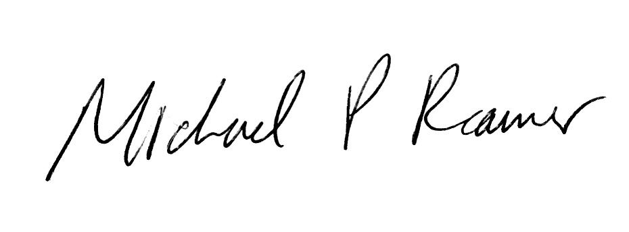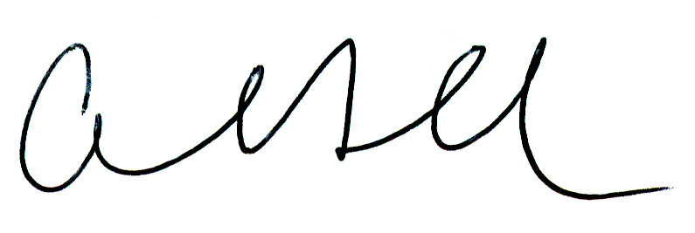
President Secretary

