|  |  |
| --- | --- |
|  | * MedImpact **Consumer Portal** |

User Guide

MAY 2021

Contents

Introduction to the Consumer Portal 1

System Requirement 1

Supported Browsers 1

Getting Started – Member Registration 2

Home Page - Dashboard 5

Help Center 9

User Profile and Settings 11

Profile 11

Medical Information (MedImpact Direct Only) 14

Payment Information (MedImpact Direct Only) 15

Notification Settings (MedImpact Direct Only) 16

User Settings 18

Walkthrough Settings 19

Change Password 20

Add Other Users 22

Send Feedback 25

My Prescriptions 26

Prescription List: 26

Claims History: 29

Orders (MedImpact Direct Only): 30

Prior Authorization: 31

Tax Report: 32

Shopping Cart (MedImpact Direct Only) 35

Benefit Highlights 38

Documents 40

Drug Price Check 41

Local Price: 42

Mail Order Price: 43

Savings Calculator: 44

Pharmacy Locator 45

Specialty Prescriptions 47

**Introduction to the Consumer Portal**

Welcome to your Health Plan Pharmacy Benefits Website! This user guide will help you familiarize yourself with the website by using non-specific member information to provide visual examples.

The Consumer Portal is your online resource to your pharmacy benefits. You can easily access tools and info you need for healthier, more informed choices.

You will have access to:

* Your pharmacy benefit information
* Find drug costs
* Obtain drug information
* Locate in-network pharmacies
* Print tax documents
* See claim history details

For members with MedImpact Direct, you also will be able to:

* Refill mail-order drugs or renew expired mail prescriptions
* Review and pay balance due
* Review order status
* Get reminders and alerts via text message, email, or phone call
* Manage account information
* Ask the pharmacy to obtain a new prescription from prescriber
* Ask the pharmacy to transfer an existing prescription to mail from retail pharmacy(ies)

System Requirement

You can access the MedImpact website on your desktop and mobile devices.

**Supported Browsers**

We suggest using the below MedImpact supported Internet and mobile browsers, which may include:

* Internet Explorer v. 11 and later versions
* Google Chrome 52.0
* Mozilla Firefox 45.0
* Apple Safari 11
* Microsoft Edge

**Getting Started – Member Registration**

The MedImpact Website is [www.medimpact.com](http://www.medimpact.com)



To begin, click Sign in.

You will need to register in order to set up an account. You will only need to register one time. Please have your member identification (ID) number available. You can find your member ID number on your prescription benefits card.

To register, please click on the link labeled as “Create an Account” which is located beneath the Username and Password boxes, as shown below:

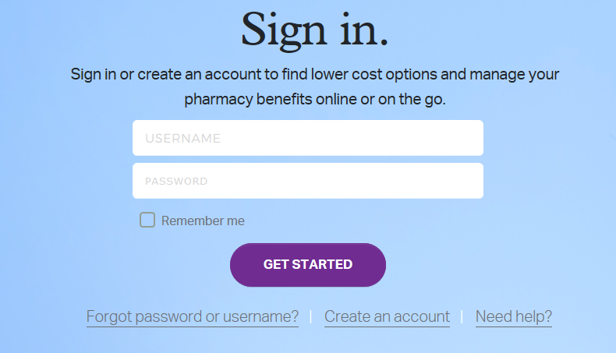

After you click on this link, you will need to provide:

* Your member ID number
* Your first and last name
* Your date of birth

For help locating your member ID number on your member card, click on the  icon.

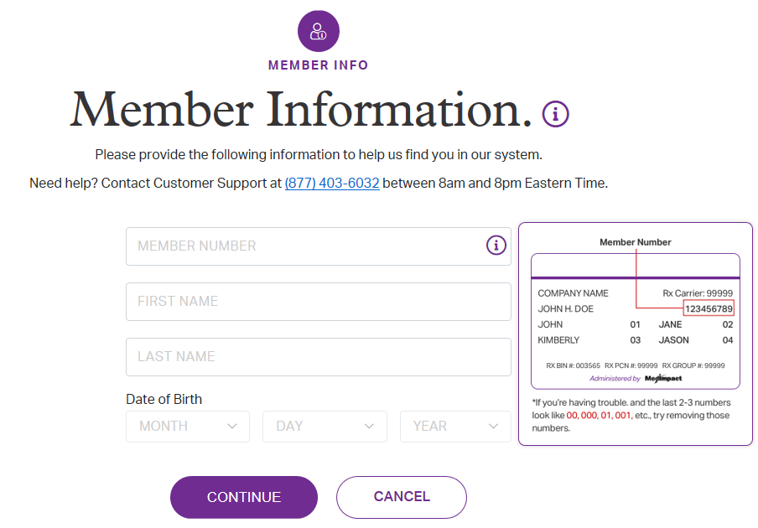

Then click “Continue”.

Next, you will need to take the following steps to complete the registration process:

* Enter your email address
* Choose a username
* Enter a password
* Agree to the legal statements and conditions
* Review the Terms of Use and Privacy Policy located at the bottom of the page

Then click ‘Finish’.

An email will be sent to the email address entered. You will need to confirm your email by clicking the ‘confirm email’ button to complete registration.

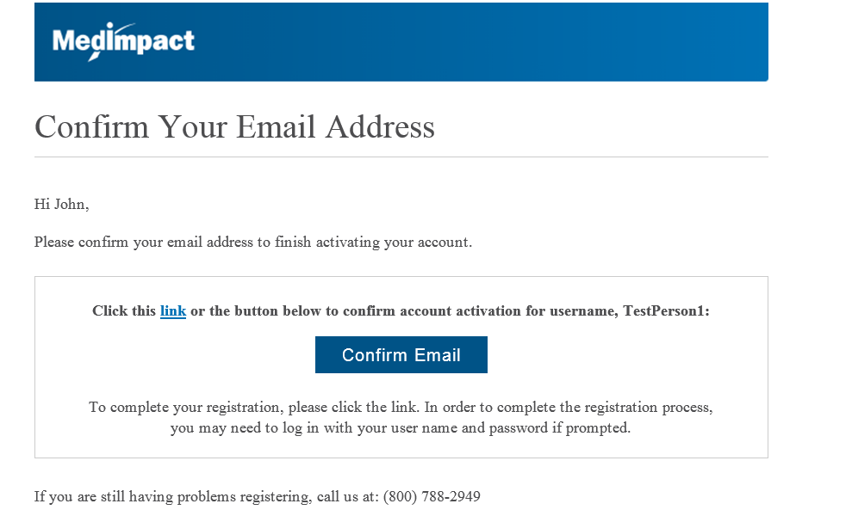

When you have confirmed your email, you will then be sent to the login page.  
You will need to sign in with your username and password.

This will complete the registration process.

**Home Page - Dashboard**

From the home page, you can access the dashboard.

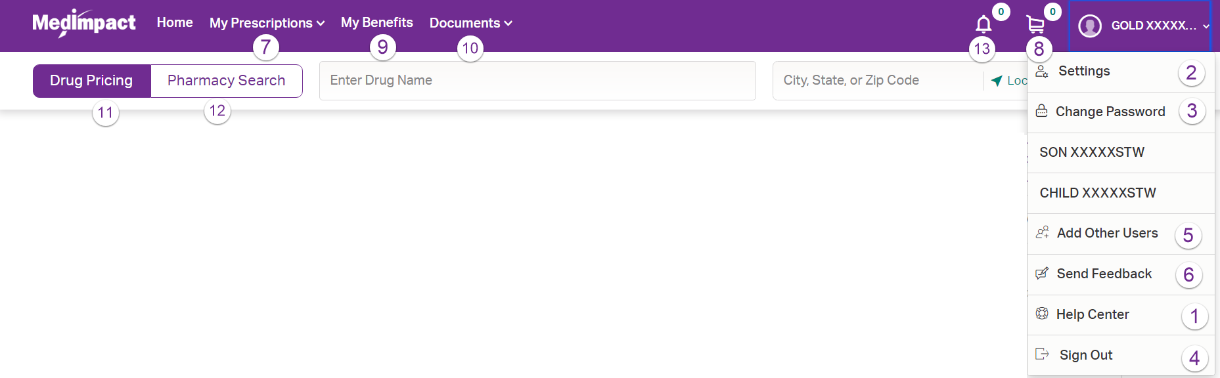

The dashboard header includes:

1. Access to the Help Center menu
2. Access to your User Profile and Settings detail
   * Profile
   * Allergies and Health Conditions
   * Payment Information
   * Alerts & Notifications
   * Register and view Dependents (User Settings)
   * Walkthrough Settings
   * Sign Out
3. Change Password
   * Account Information
   * Security Settings
4. Sign Out
5. Add Other Users
6. Send Feedback
7. My Prescription menu
   * Prescription list
   * Claims History
   * Order History (MedImpact Direct Mail Order Only)
   * Tax Report
   * Drug Information
   * Prior Authorization
8. View your Shopping Cart (MedImpact Direct Only)
9. Benefit Highlights
10. Access a Listing of helpful Documents
11. Drug Price Search
12. Pharmacy Locator
13. View Alerts & Notifications

In addition to the dashboard header, you can see an overview of the following widgets in the dashboard that can be re-ordered or hidden by pressing the “Dashboard Settings” button:

* My Prescription
* Benefit Overview
* My Dependents
* Savings opportunities
* Order Status (MedImpact Direct Only)
* Prior Authorization
* Next Steps/Profile/My Account

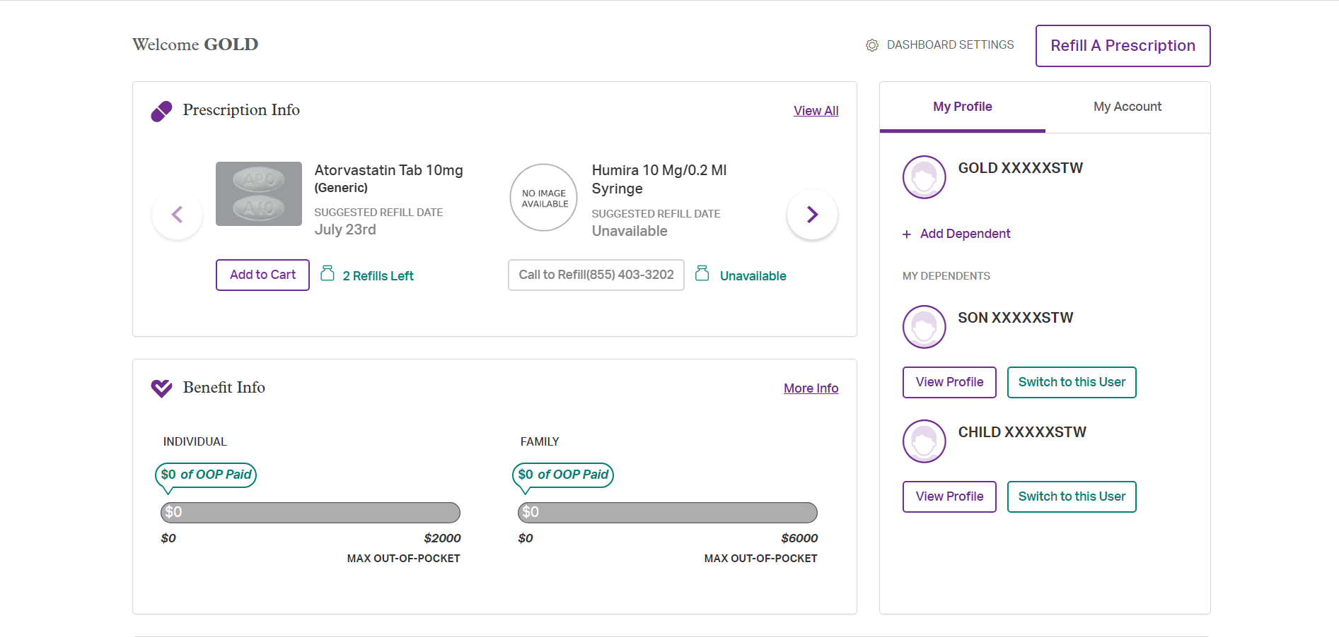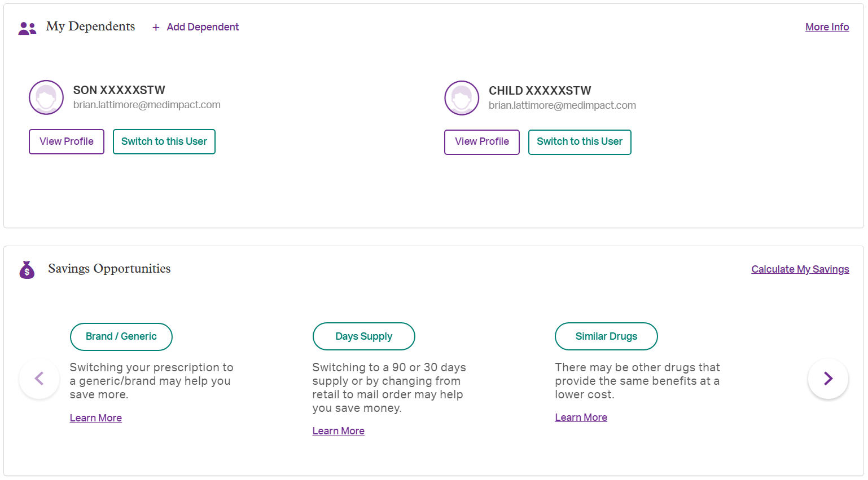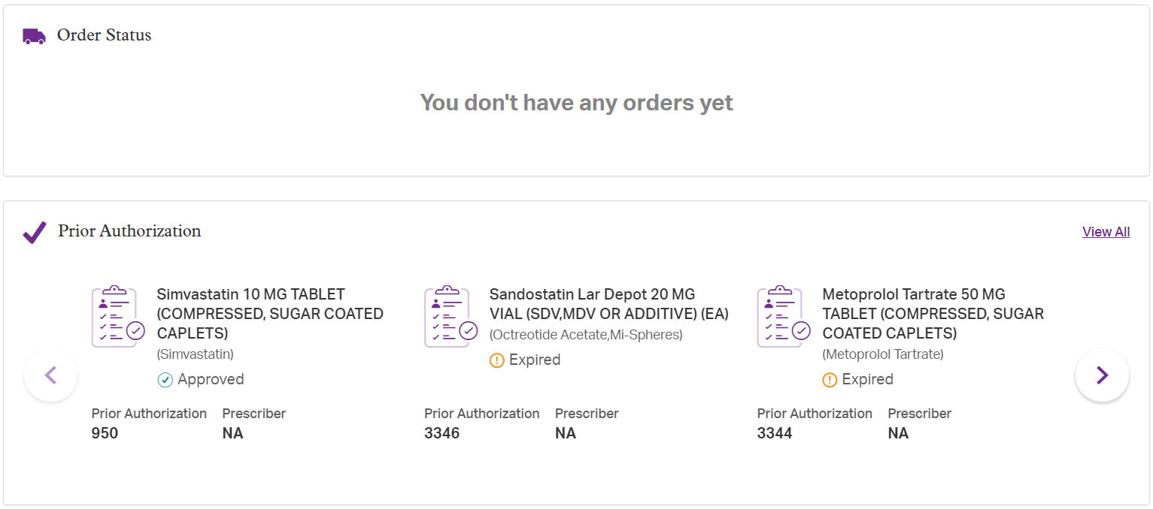

**Help Center**

The home page will show your name in the upper right side of your screen.

Help Center in the dropdown includes the following information below:

* Contact Support
* Common Questions
* Glossary
* Generic Drug Guide

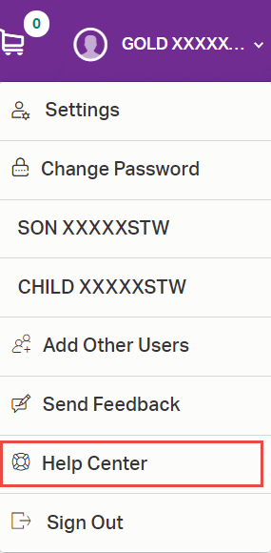 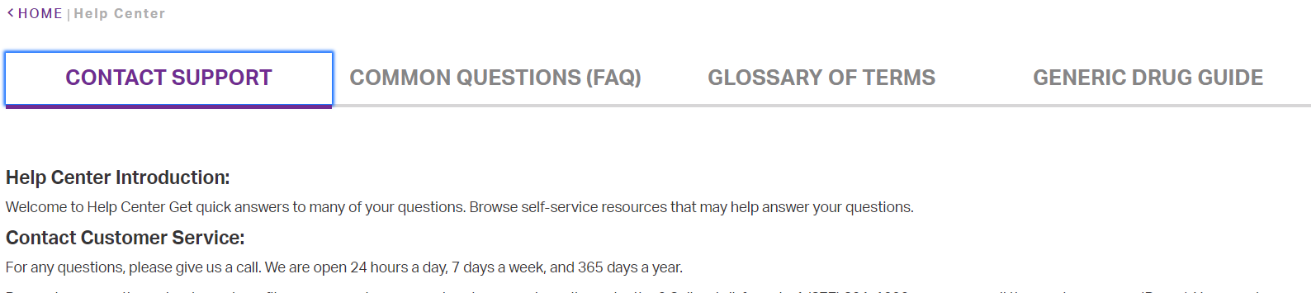

Contact Support will provide information on:

* Customer Service contact
* MedImpact Direct Mail Order
* MedImpact Direct Specialty

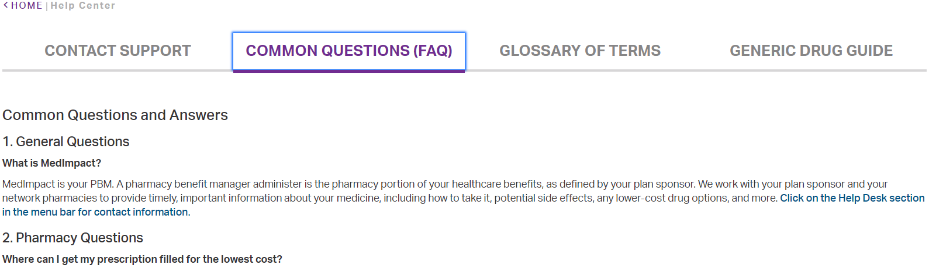

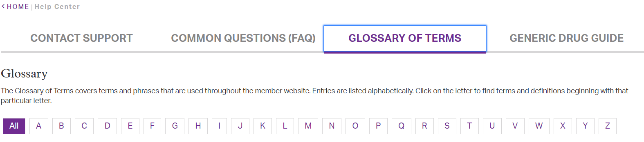

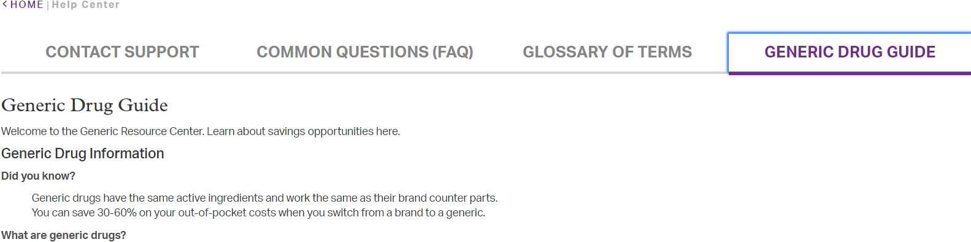

**User Profile and Settings**

The Settings menu displays when you select from the home page drop down next to your name in the upper right side of your screen.

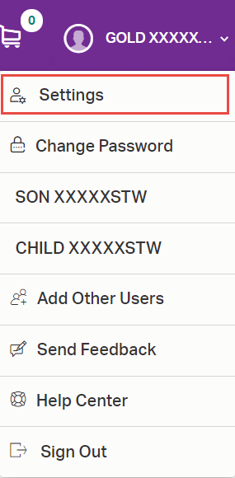

In the Settings feature you’ll see the following (some elements are MedImpact Direct Mail Order only):

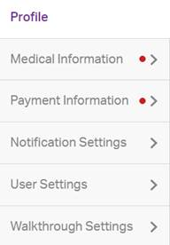

User Profile is the default and an overview of each feature is provided below:

# Profile

* View or edit your address and phone number
* View or edit your email address
* View and print a temporary Prescription Benefit ID card

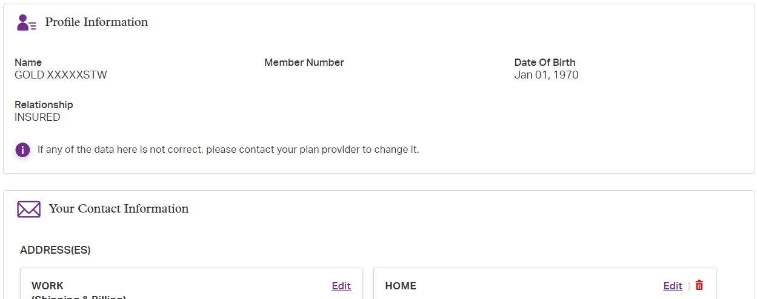

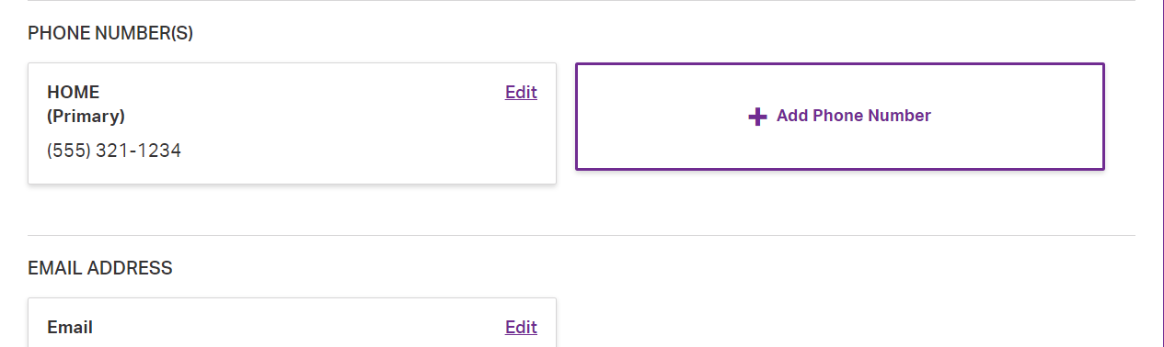

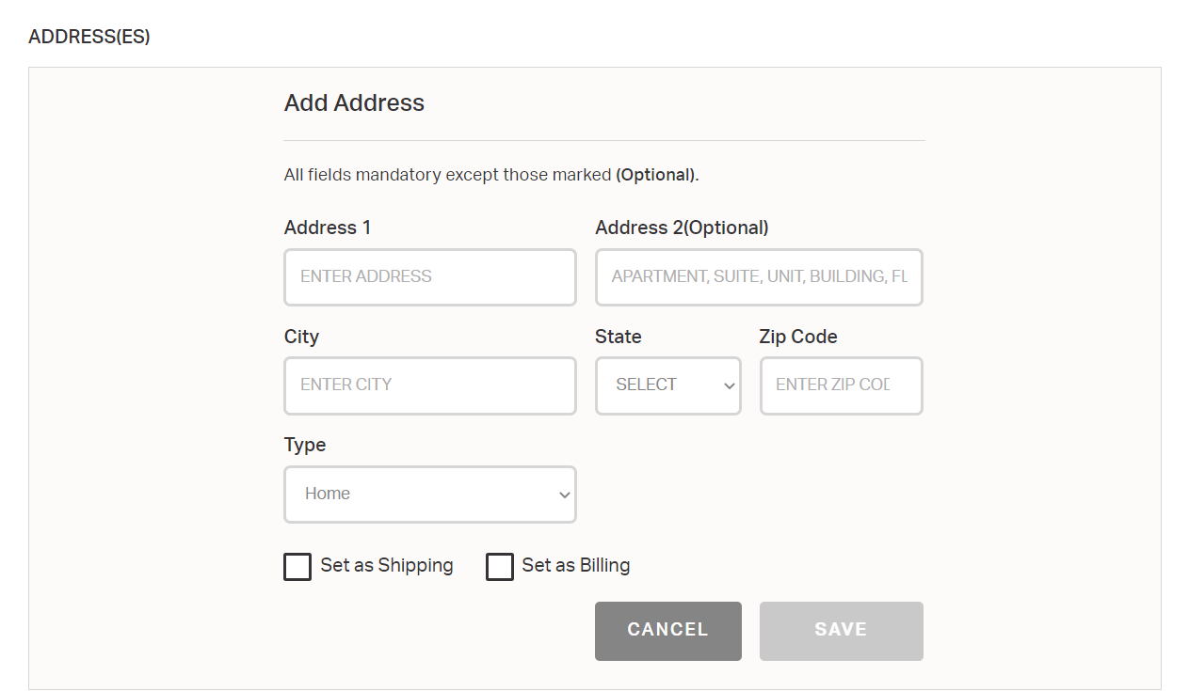

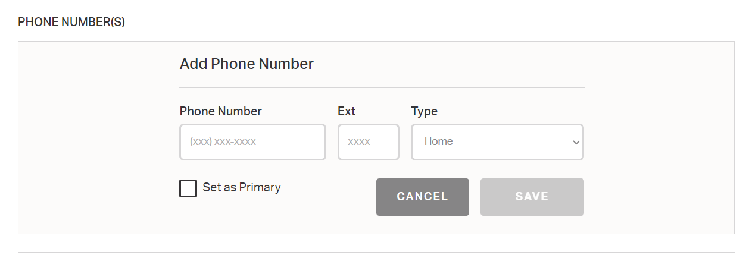

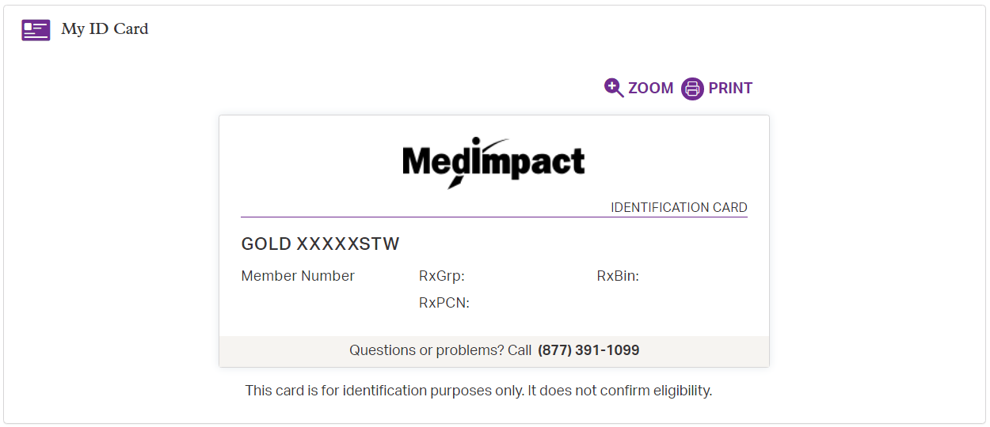

# Medical Information (MedImpact Direct Only)

* View and update allergies and health condition info

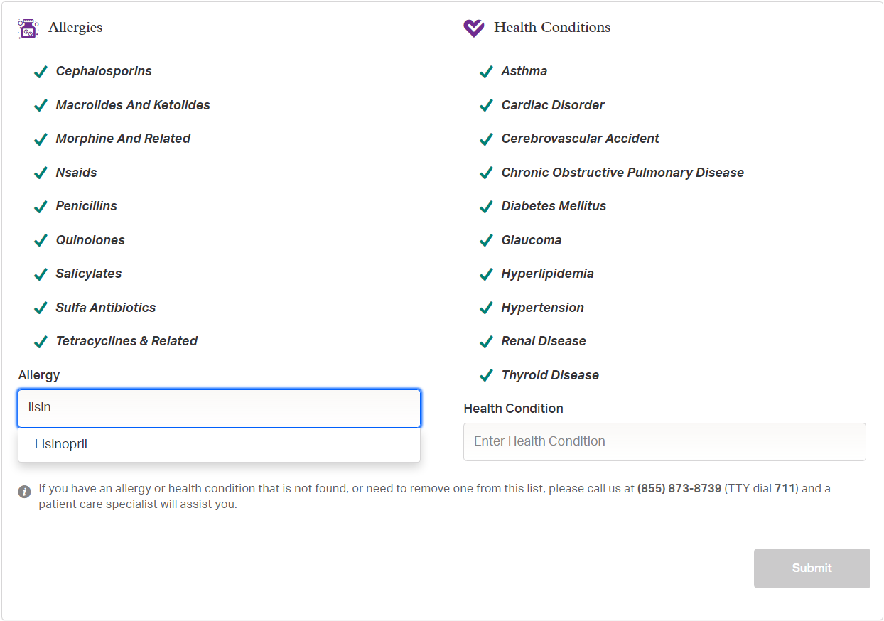

# Payment Information (MedImpact Direct Only)

* View, add and update payment info

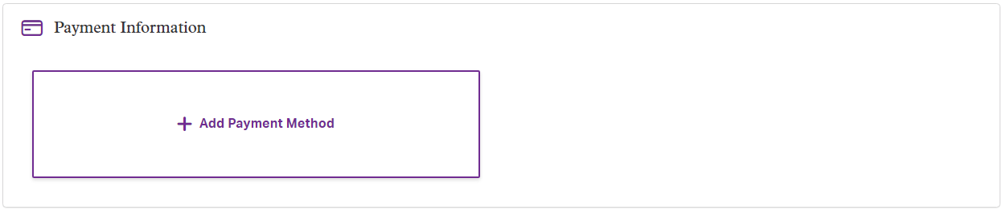

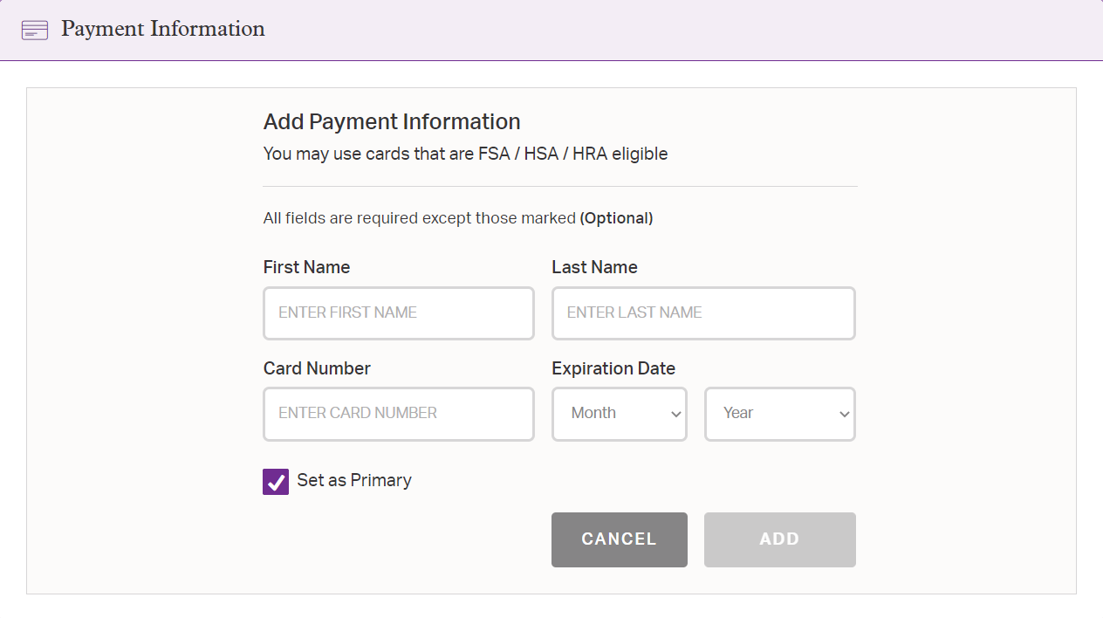

# Notification Settings (MedImpact Direct Only)

* View and update alerts for:
  + New prescriptions
  + Refill reminders
  + Shipping Notifications

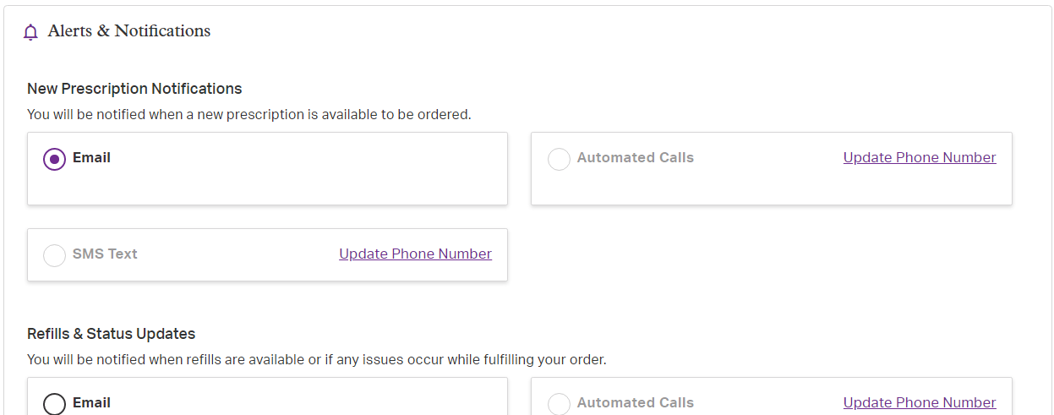

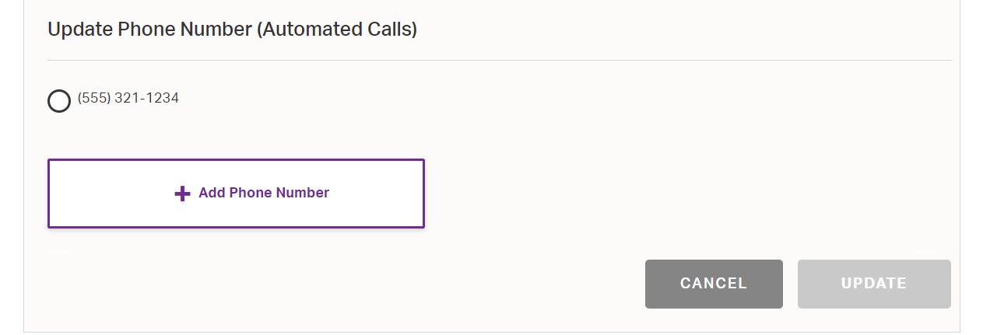

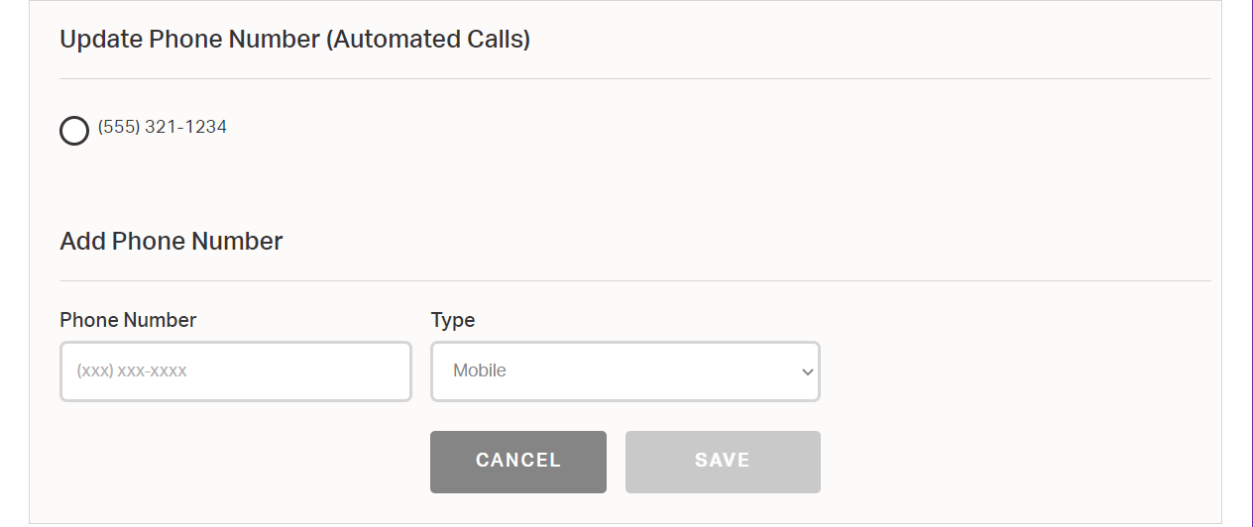

# User Settings

(Please Review Privacy Policy for additional details)

* Request member view access.

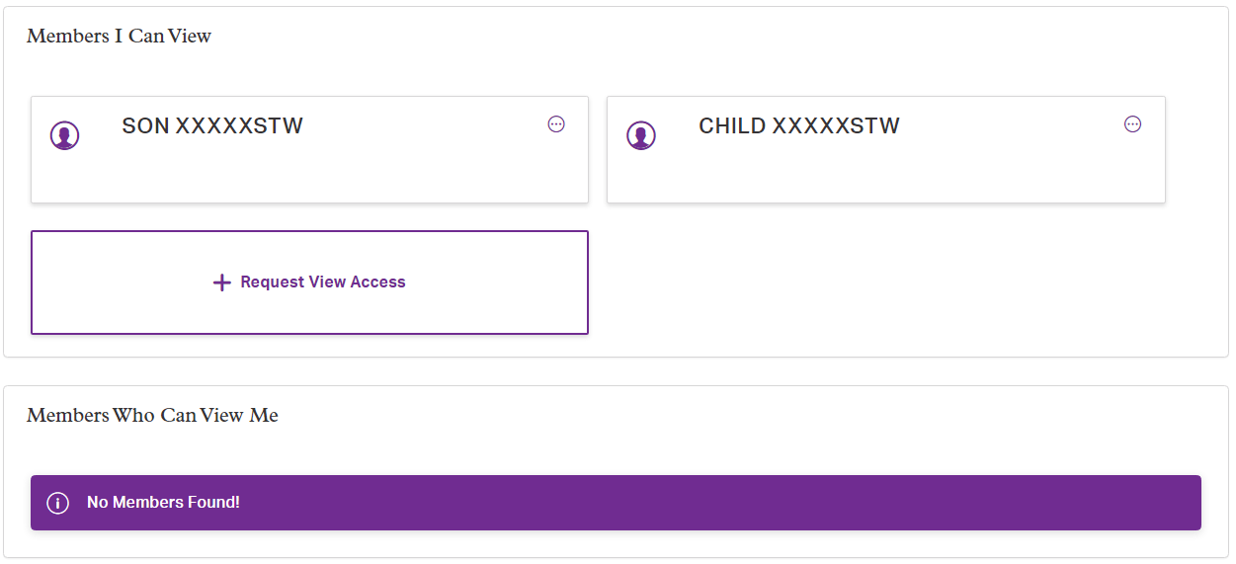

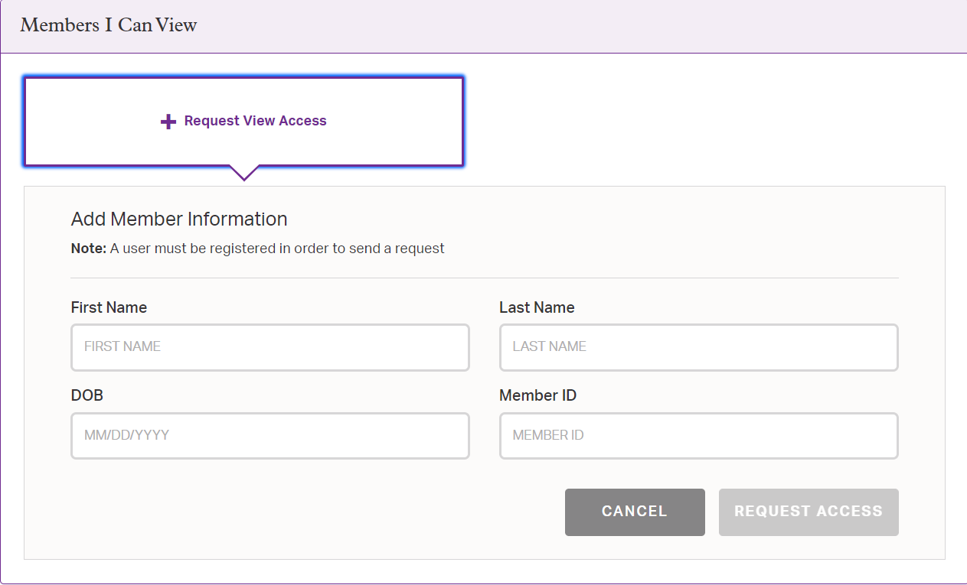

# Walkthrough Settings

* View and update settings:
  + Pharmacy Locator
  + Dashboard
  + Prescriptions
  + Drug Price Check
  + Settings

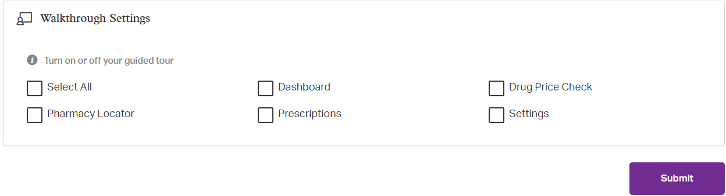

**Change Password**

Next on the dropdown, you will the find ‘Change Password’ feature:

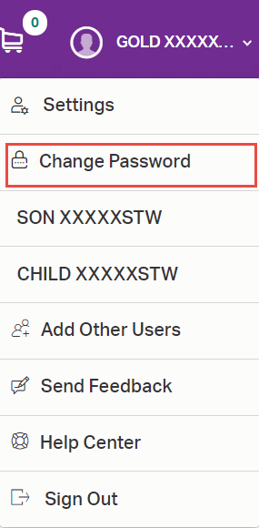

The Change Password screen will feature will bring you to the following screen:

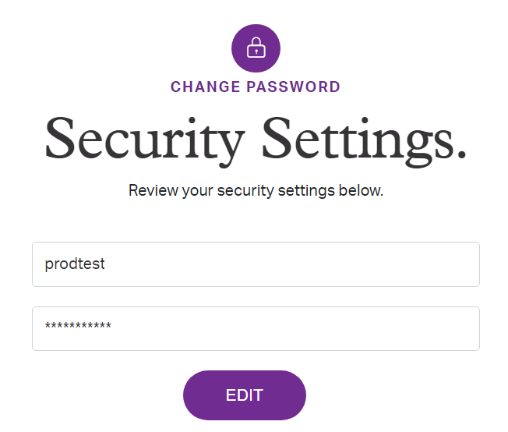

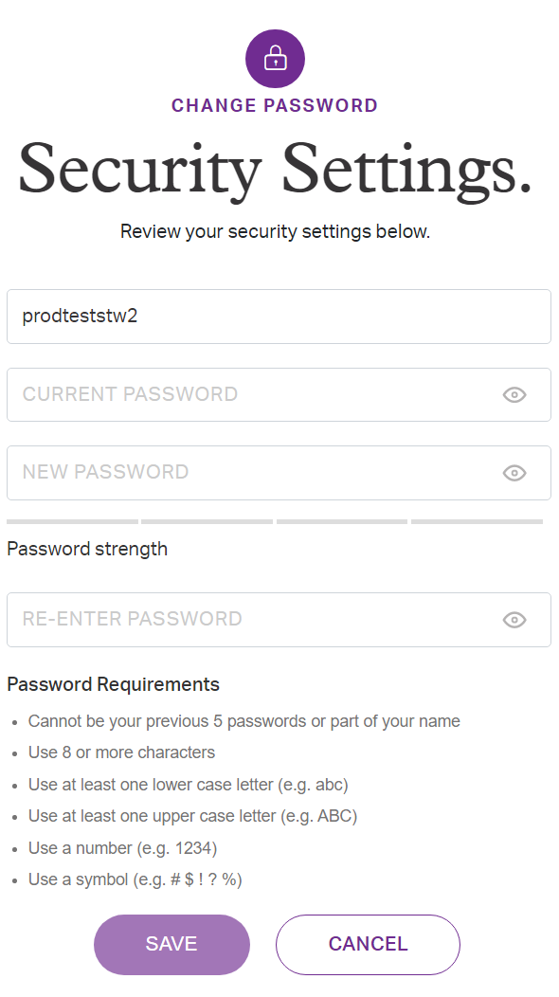

**Add Other Users**

Next on the dropdown, you will the find ‘Add Other Users’ feature. This will bring you into the “User Settings”. Here you can request view access to dependents and other users. You can also control who can view your profile (review Privacy Policy for additional information):

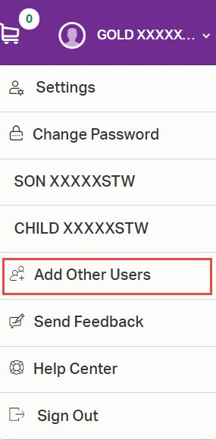

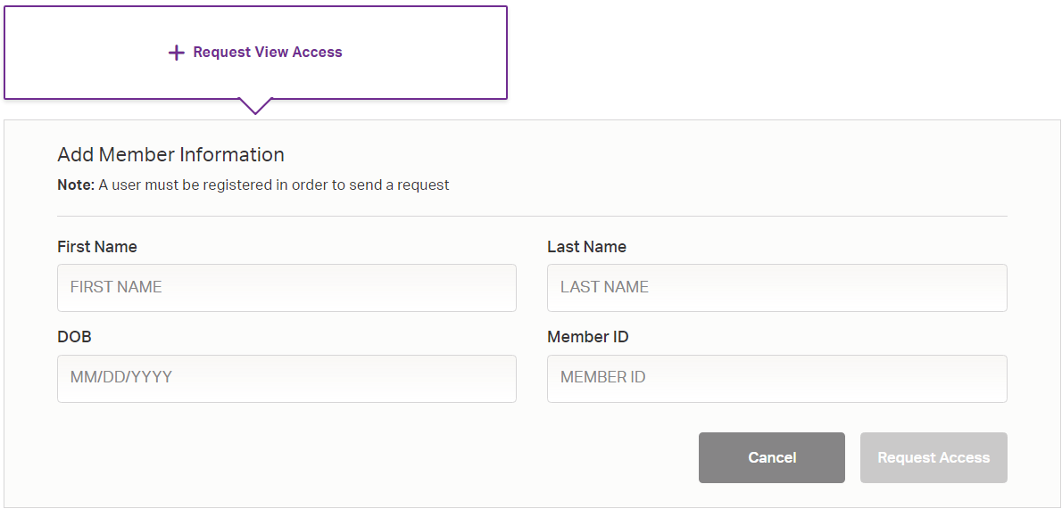

Dependents under 12:   
As the employee or spouse (if applicable), you will automatically be granted access to dependents under the age of 12.

Users age 12 and over:   
To gain access to any user 12 or over, that user will need to first be registered. Once the user is registered, you will need to request access to their account.

There are a few ways to do this. They are as follows:

1. You can click “Add Other Users” in the header drop down.
2. You can click “Add Dependent” in the “My Profile” section on the dashboard
3. You can go to the “User Settings” section in “Settings”.
4. You can click “Add Dependent” in the “My Dependents” section in the dashboard

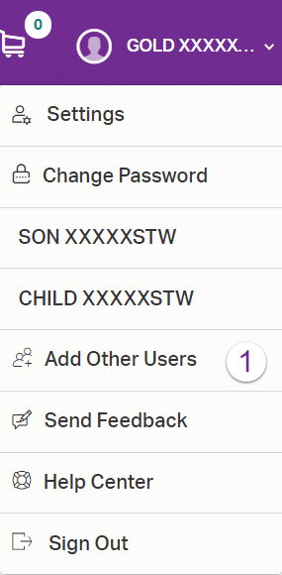 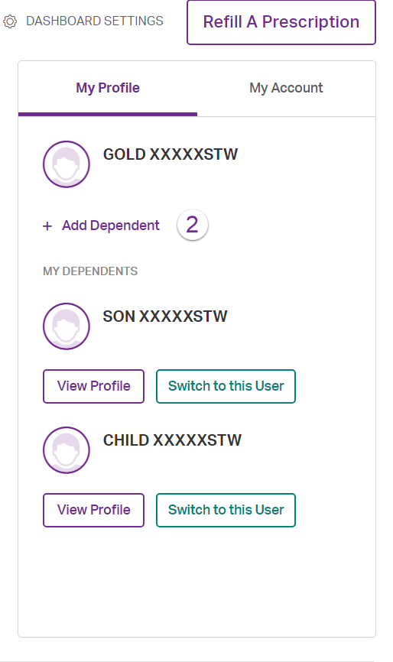

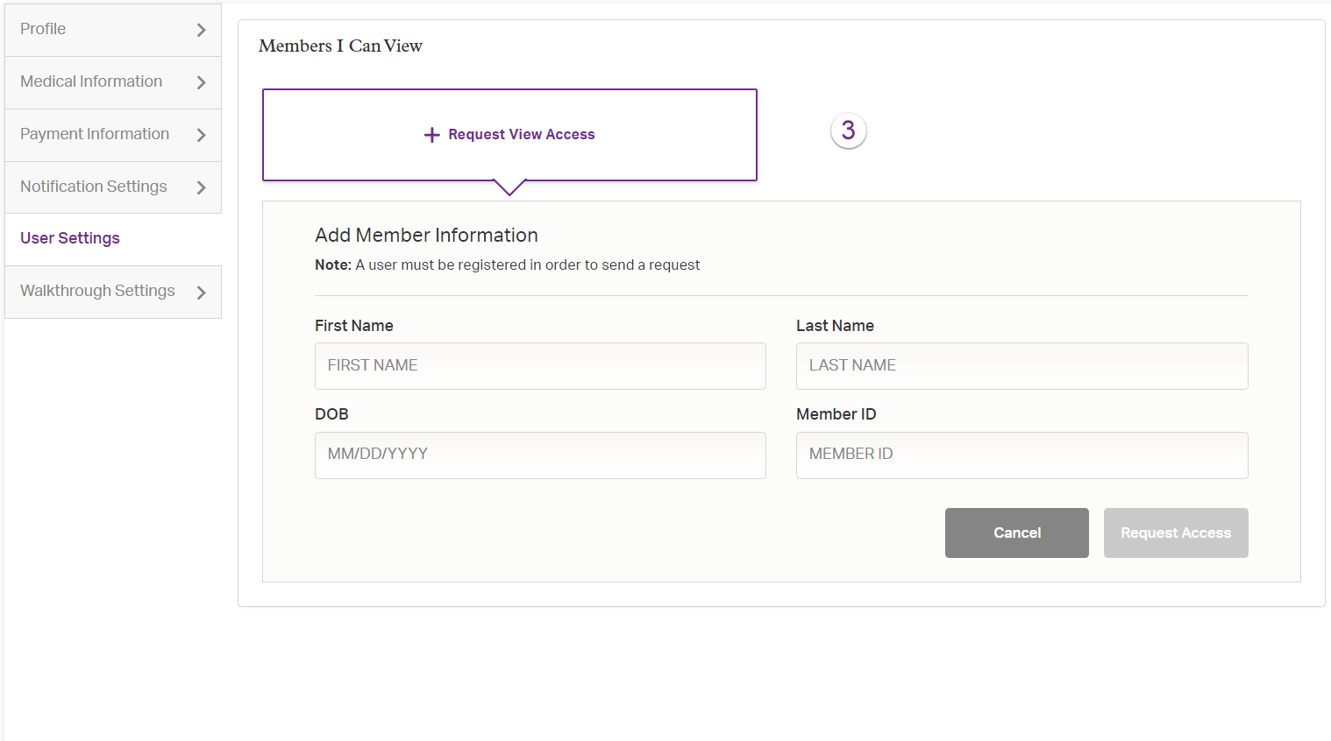

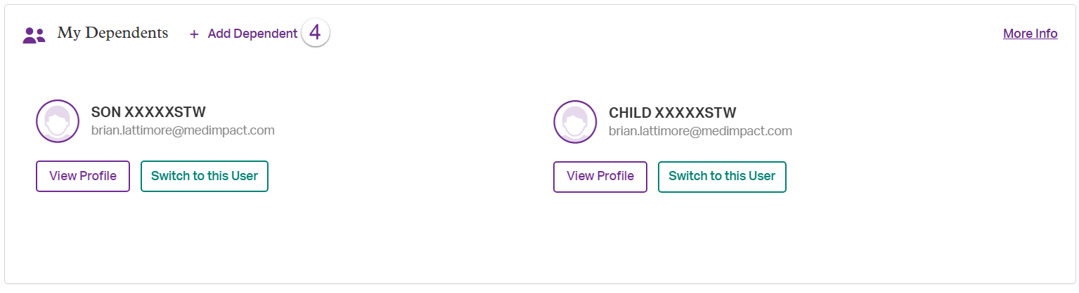

This will open the member detail screen. To complete the registration, you will need to provide:

* The user’s member ID number
* The user’s first and last name
* The user’s date of birth

When you click continue, a request will be sent to the user’s account. Once the request is accepted, you will be able to switch to that user’s profile.

**Send Feedback**

The ‘Send Feedback’ feature displays the form for feedback and submit:

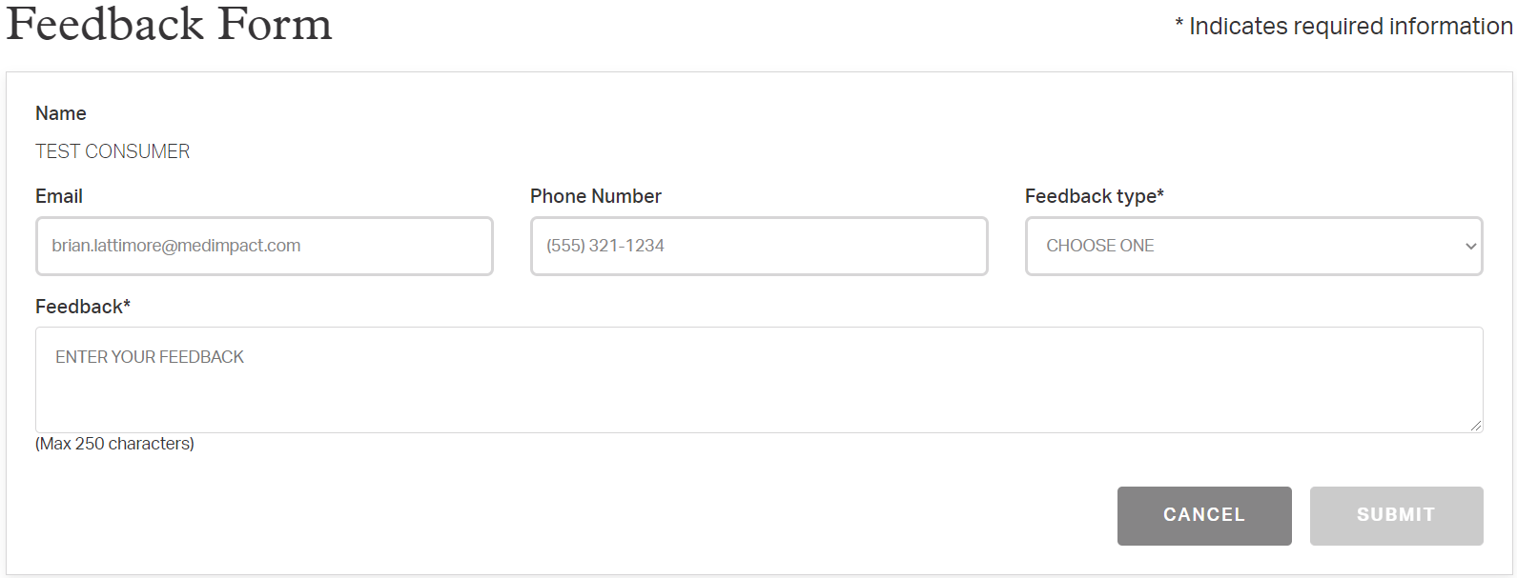

**My Prescriptions**

The My Prescriptions menu located on the dashboard gives you access to the following topics:

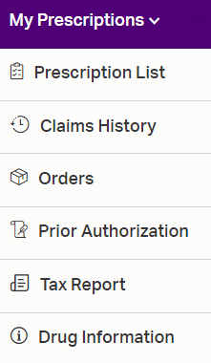

# Prescription List:

You can see a listing of your prescriptions.

Each prescription will show the following:

1. Drug name
2. Refill status (active, expired, etc.)
3. Recommended refill date
4. Cost
5. Action buttons (Show pricing, etc.)
6. Savings opportunities (if available)
7. Specific refill information (if available)
8. More details

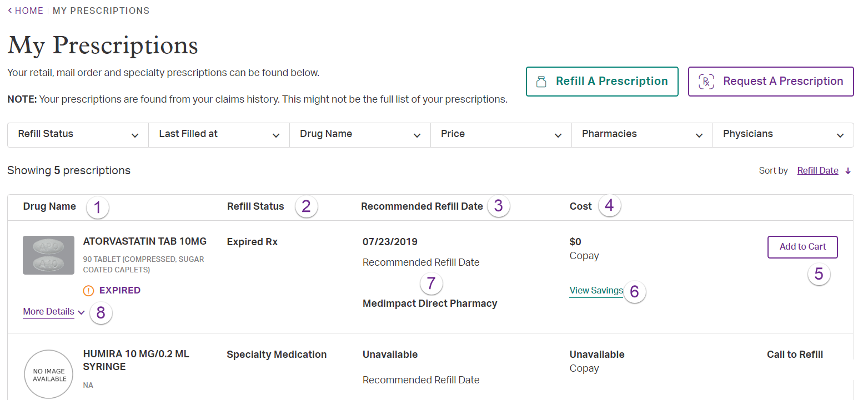

You can also filter and sort your prescriptions on the following:

1. Refill Status (refillable, expired, etc.)
2. Last Filled at (retail, mail order, specialty)
3. Drug Name
4. Price range
5. Pharmacy name
6. Physician name
7. Sort by (Refill Date, Drug Name, Drug Price, Pharmacy, Physician)
8. Change sort order

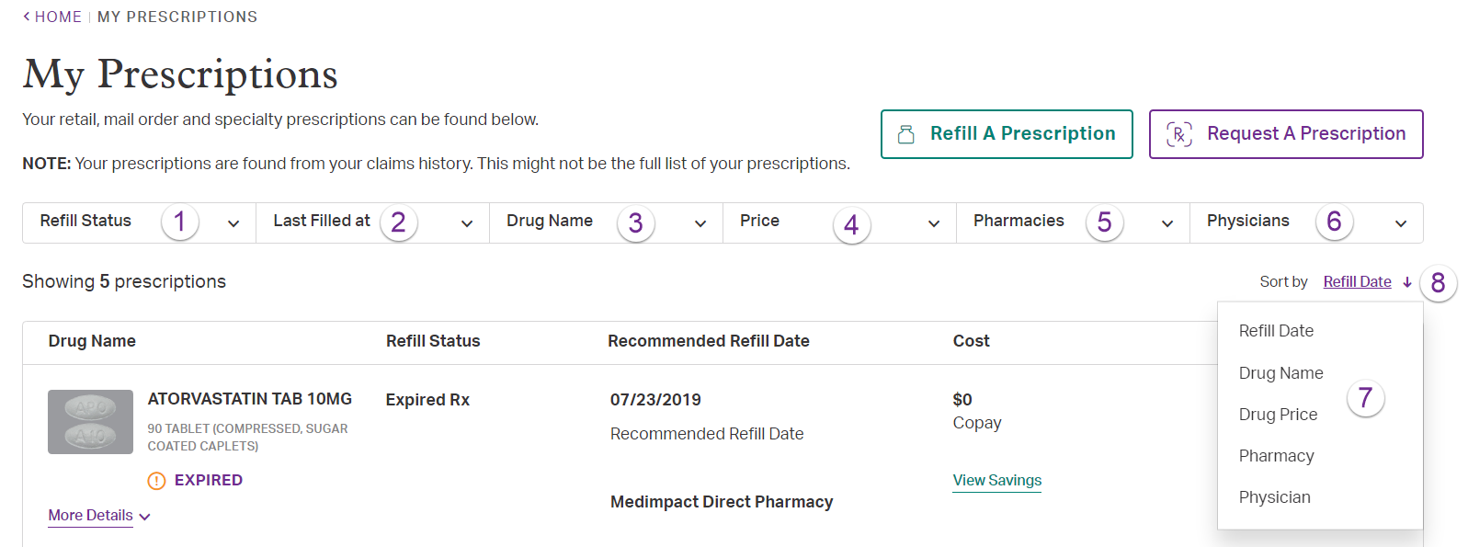

For MedImpact Direct Users, you can request a new mail-order prescription from MedImpact Direct Mail Order. Simply click on the ‘Request a Prescription’ button. Next, enter the required details. Then click on ‘Submit.’

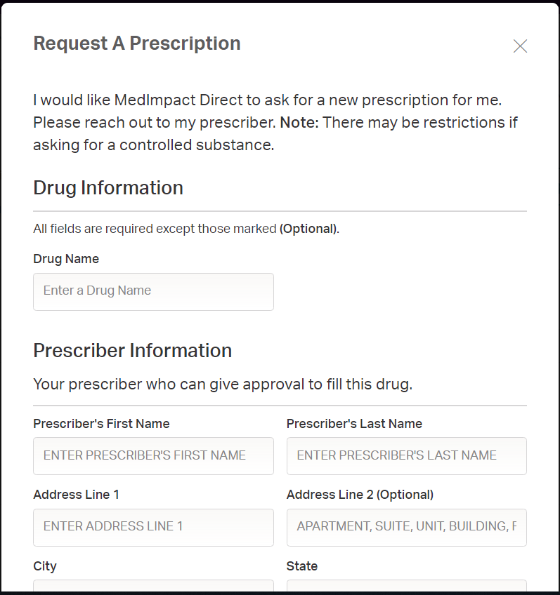

Your prescriber must send the prescription directly to MedImpact Direct Mail Order via ePrescription or by fax at (888) 783-1773.

You can also request to refill a prescription. Simply click on the ‘Refill Prescription’ button. Next, enter the required details to search a drug to refill and then add to cart.

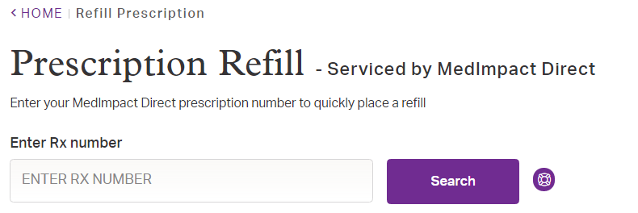

# Claims History:

You can see and print up to 3 years of prescription drug claim history.

You can filter your search on following:

1. Date range
2. Drug name
3. Pharmacy
4. Prescriber

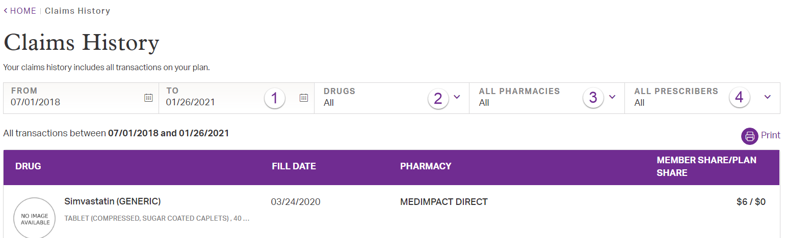

The following information shows for each claim:

1. Drug name
2. Last fill date
3. Pharmacy name
4. Member and plan cost
5. Option to print

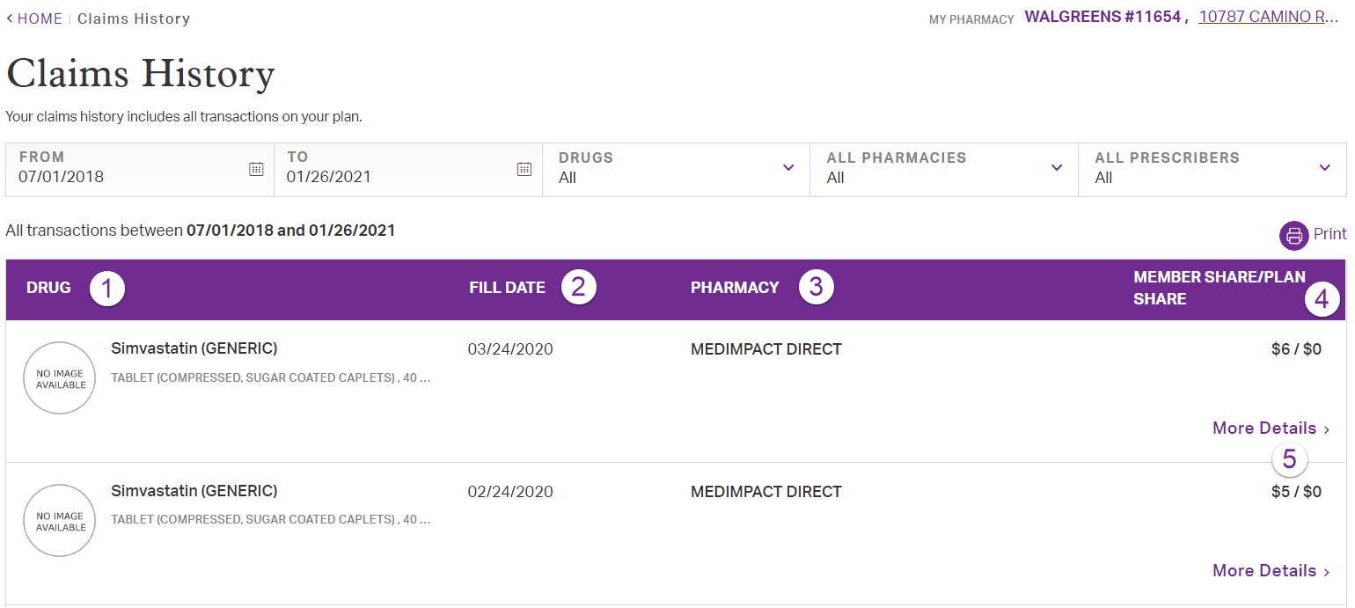

Orders (MedImpact Direct Only):

You can view any existing mail order details.

Each existing order detail will include:

* Order number
* Item ordered
* Status of order
* Tracking number
* Your cost

All Orders will display from the most recent to the oldest.

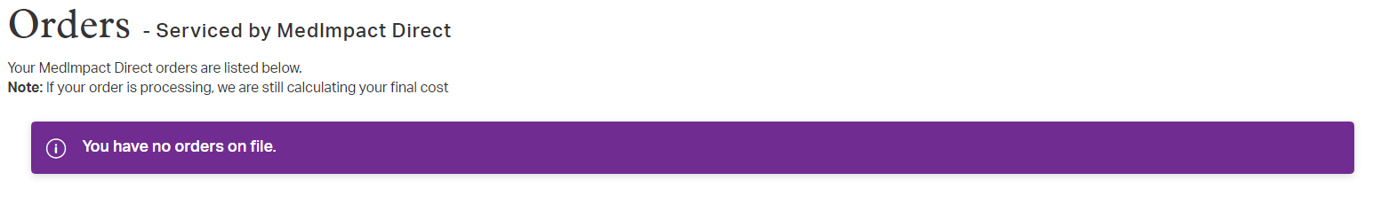

Prior Authorization:

You can view your prior authorization(s).

Each authorization will show:

1. Drug name
2. Authorization number
3. Prescriber
4. Authorization status
5. Print
6. View price link

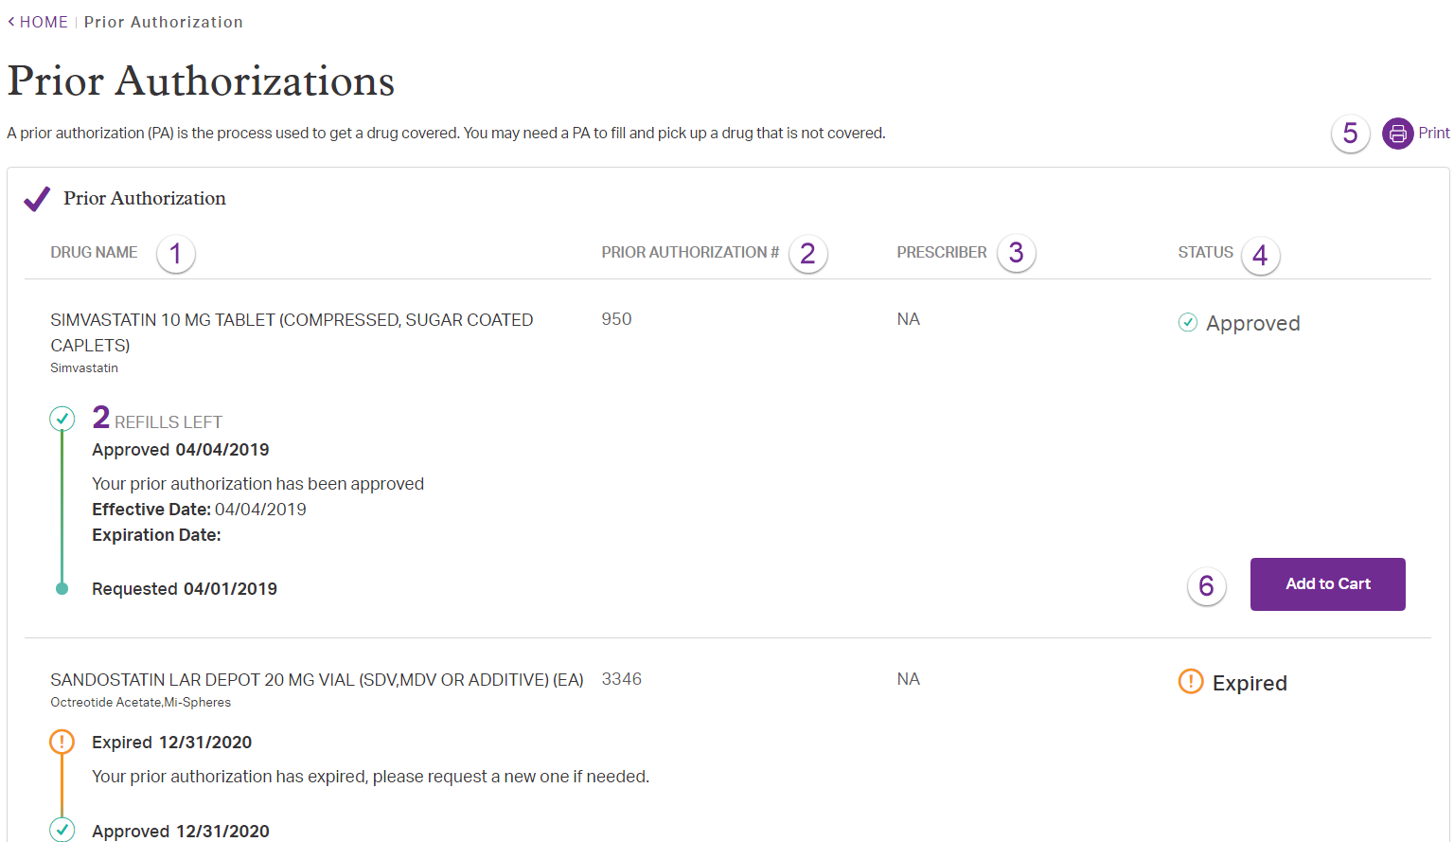

Tax Report:

You can generate, view and print a tax report.

You can create a report with multiple tax years and members. The tax year detail is based on a calendar (Jan. 1 – Dec. 31). You can print the tax report by clicking on the  icon.

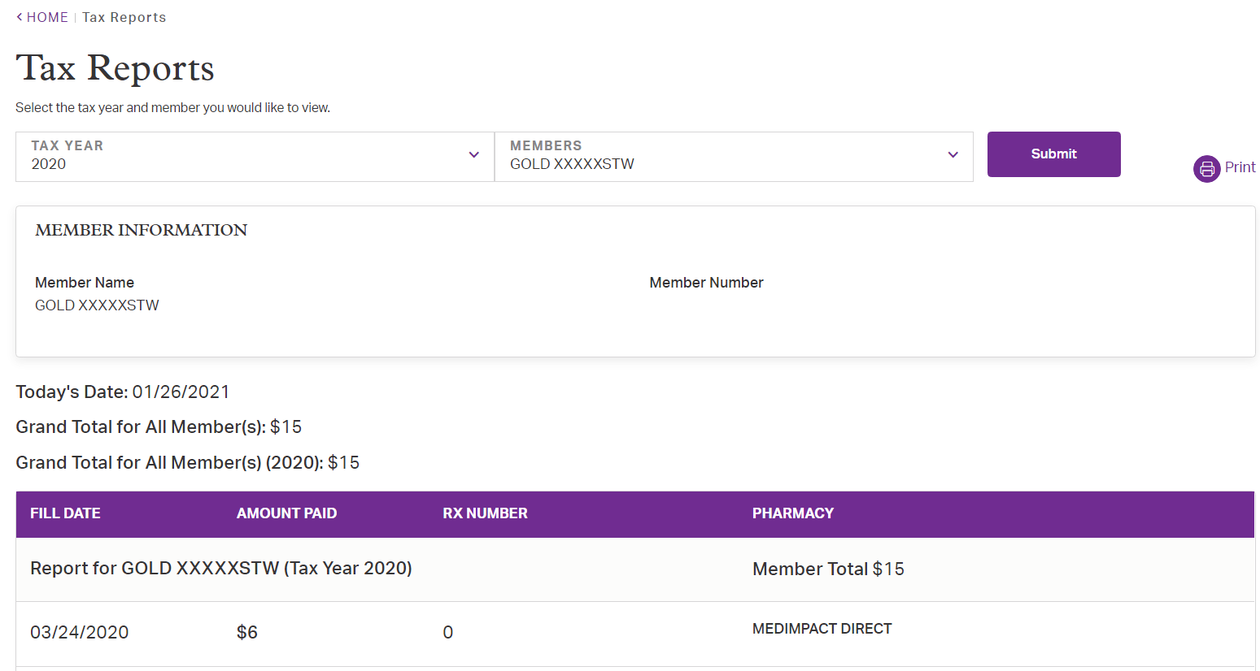   
 Drug Information:

You can search a new drug or choose from prescription.

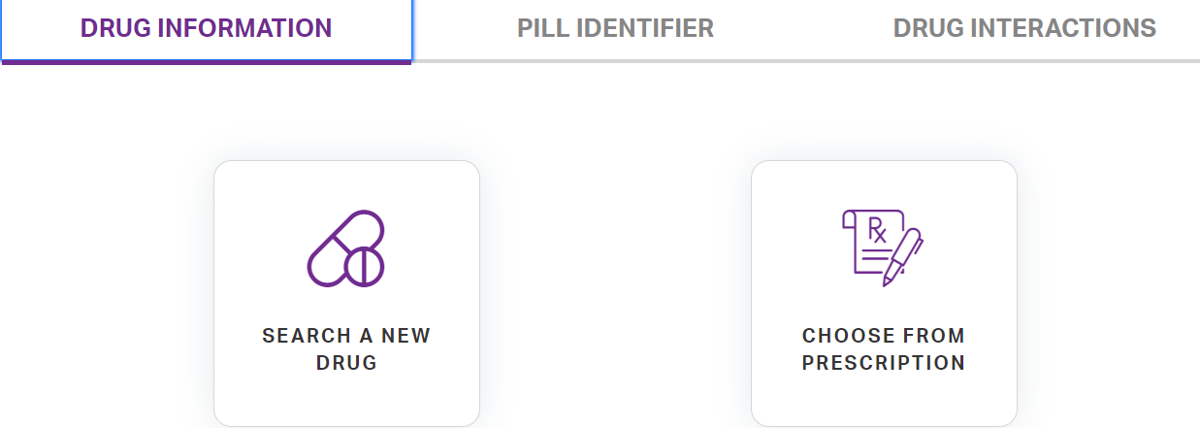

Search a Drug button allows you to choose a new drug,

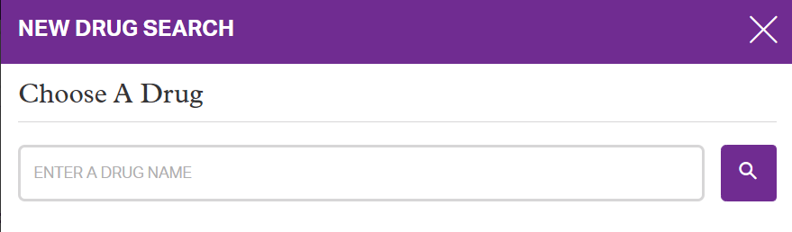

Or a drug from your prescription list

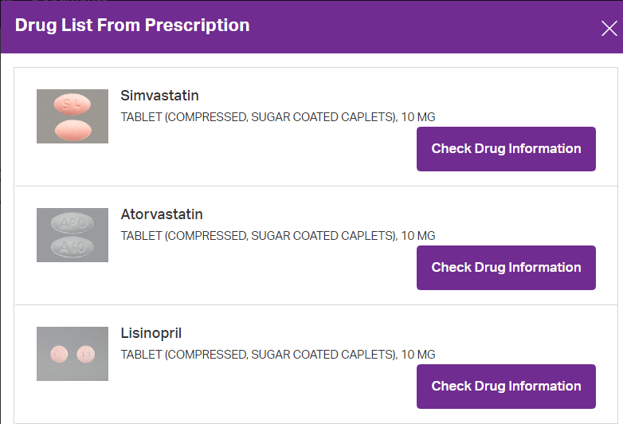

Once a drug is selected, the drug information includes important drug details such as:

* Drug Interactions
* How to Use
* Important
* Missed Dose
* Notes
* Precautions
* Side Effects
* Overdose
* Storage
* Drug Image

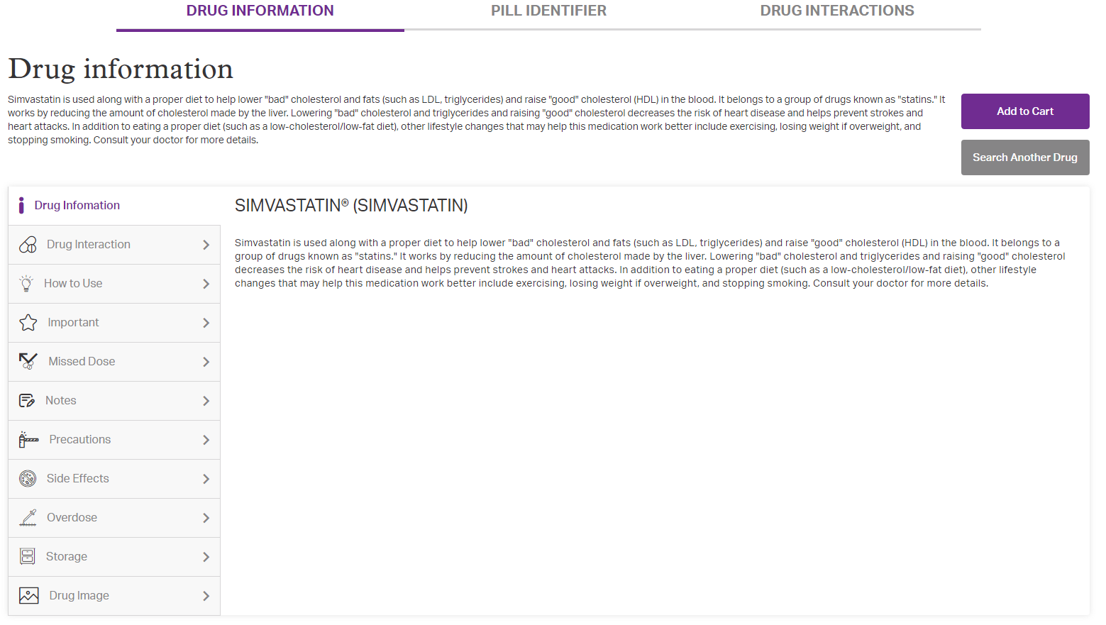

Pill Identifier button has optional search option by marking or color, to help you find the name of a drug, if you only have the pill:

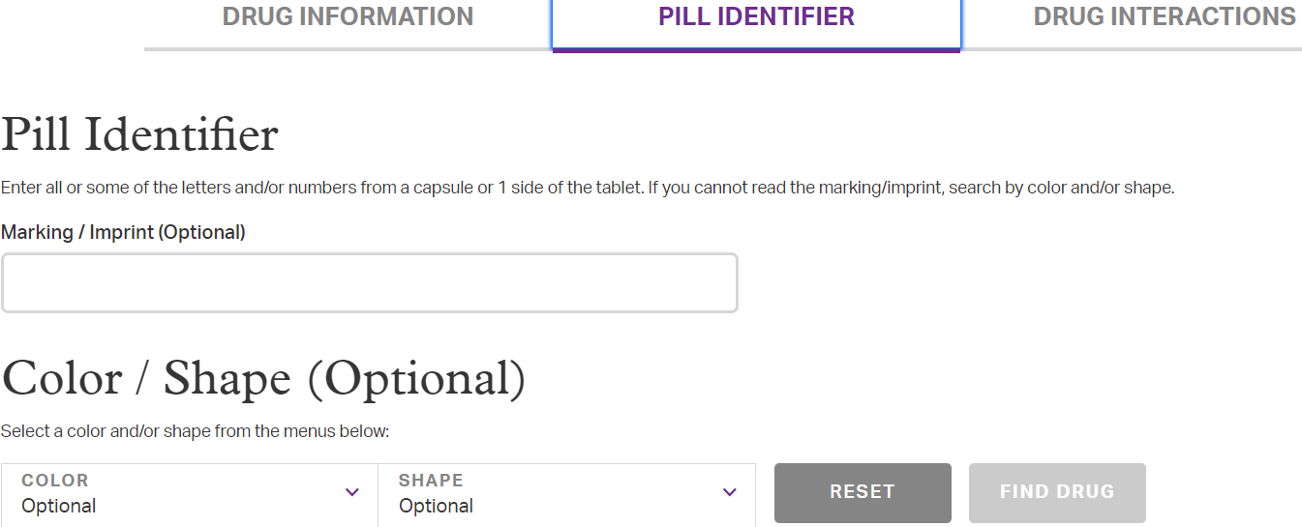

Drug Interactions feature allows to search or add from prescriptions (up to 6 drugs), and check for any interactions between those drugs:



**Shopping Cart (MedImpact Direct Only)**

The Shopping Cart is accessible through the Shopping Cart  icon on the upper right side of your screen.

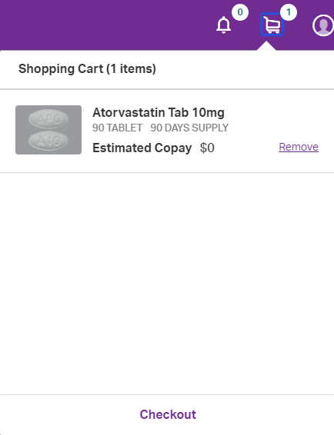

The following items are required in order to access the shopping cart

* A completed member profile which includes:
  + Street address
  + Email address
  + Phone number
  + Payment information
* An existing mail order prescription with MedImpact Direct Mail Order

You can add items to your cart by clicking on the “Add to Cart” button.

The cart icon will show a summary of your order. Clicking “Checkout” will bring you into the cart where you can see the estimated cost. The actual cost will be confirmed after the order has been processed.

1. Items in your cart
   * To remove an item, click on the Remove link in blue.
   * To move to the next step and submit your order, click on the ‘Continue’ button.

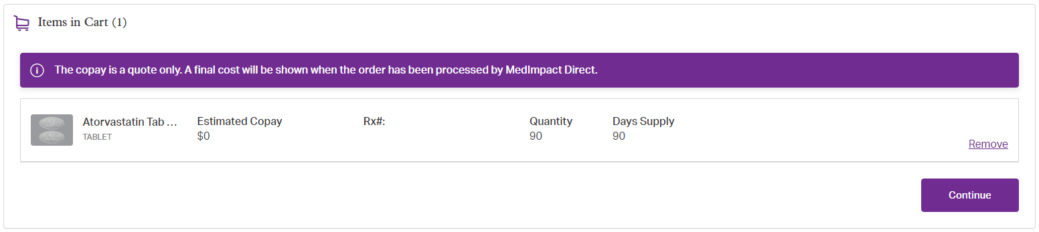

The following three steps need to be completed in order to process your order:

1. Confirm shipping address

* The shipping address
  + To change or add an address click on the Edit link.
  + To confirm the shipping address, click ‘Continue’.

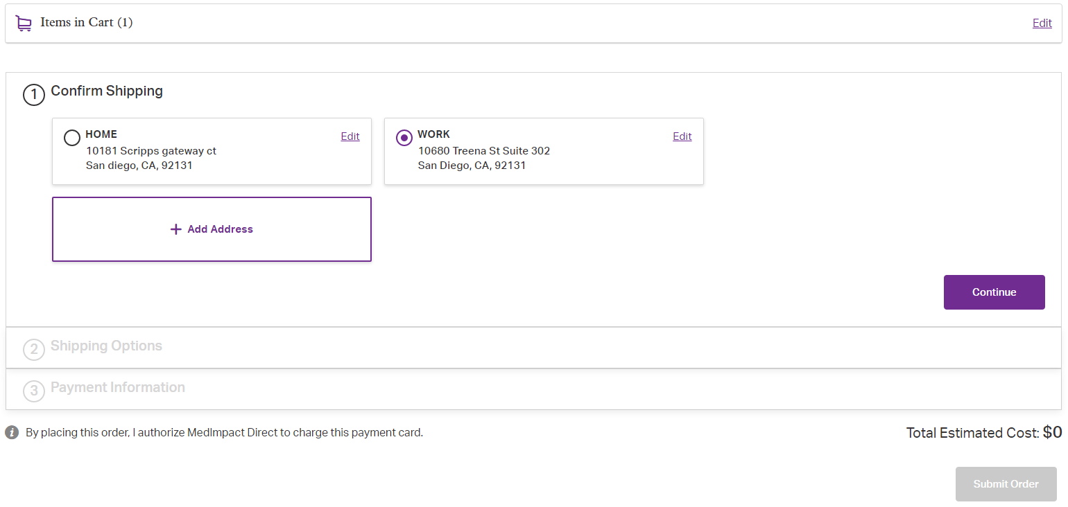

1. Confirm shipping type

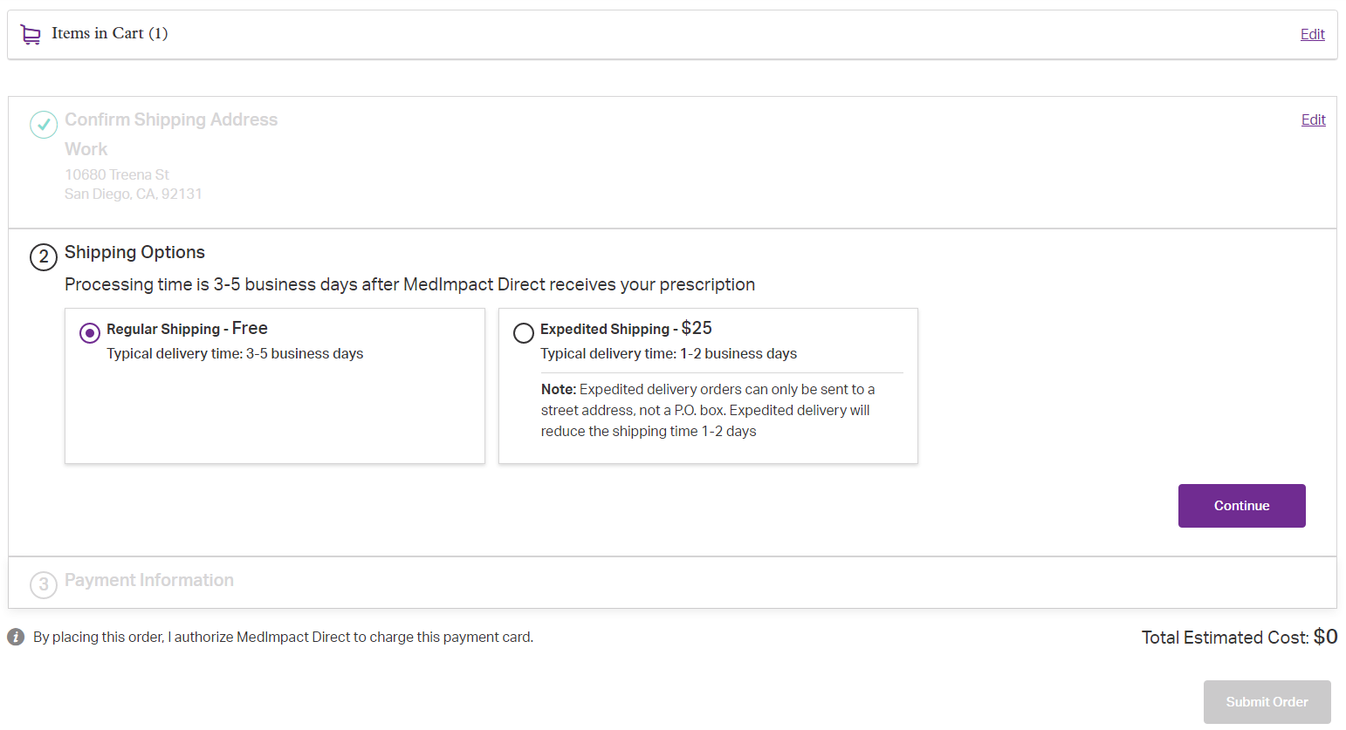

1. Confirm payment
   * The payment detail
   * To edit payment details, click on the Edit link in blue.
   * To confirm the payment detail, click Review Your Order.

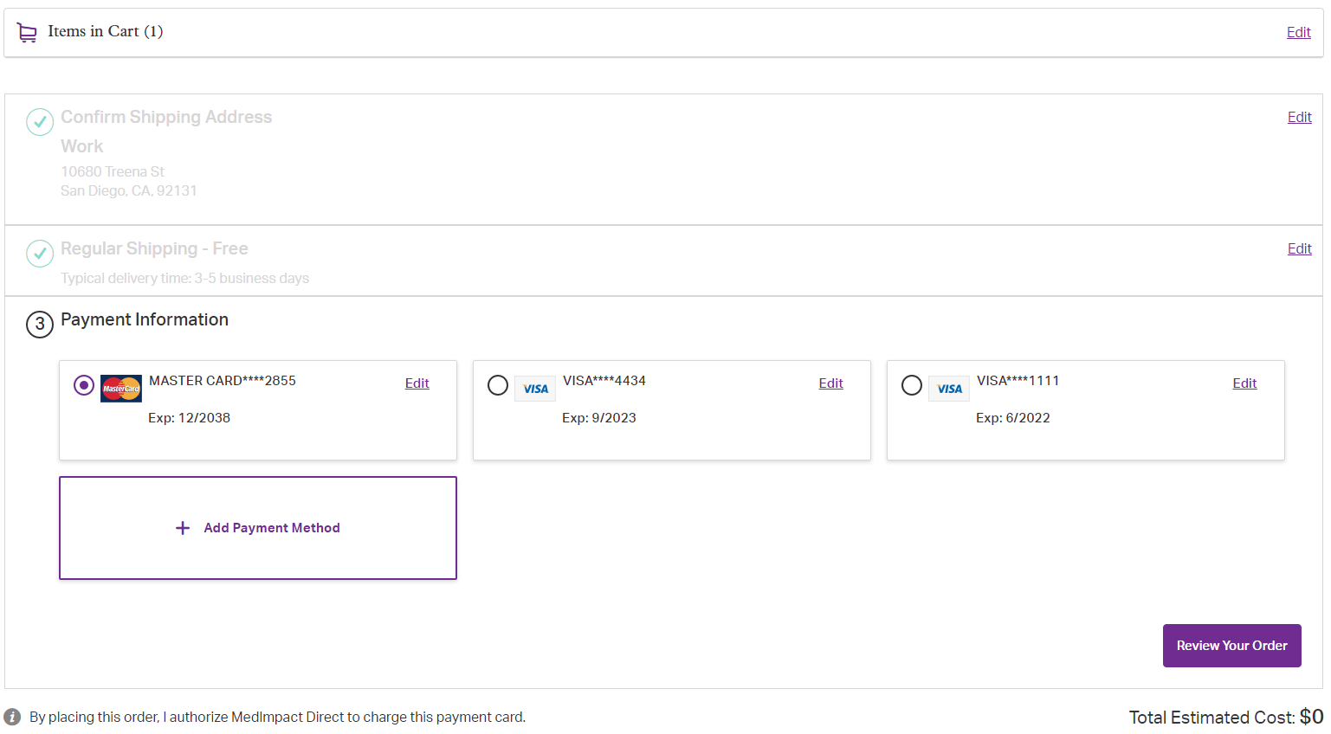

To submit your order, click on the ‘Submit Order’ button.

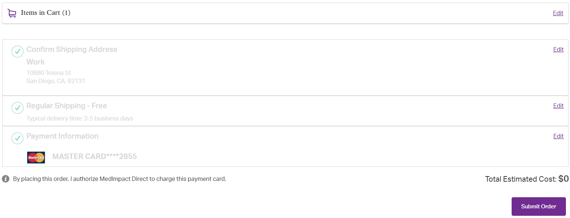 Orders can be tracked by returning to the My Prescriptions menu. From the My Prescription menu, go to Orders. Next, click on the Tracking number link in blue.

**Benefit Highlights**

You can view your benefit details as outline below:

* Copays
* Deductibles
* Benefit limits
* Accumulators
* Out of pocket maximums

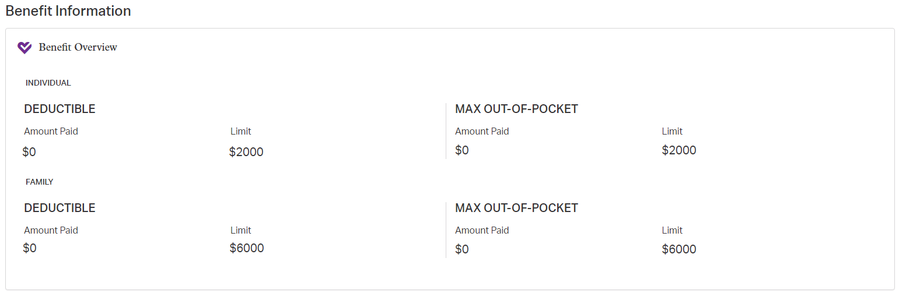

Copayment amounts will display based on the following options, if applicable:

* Retail
* Choice90
* Mail Order
* Specialty

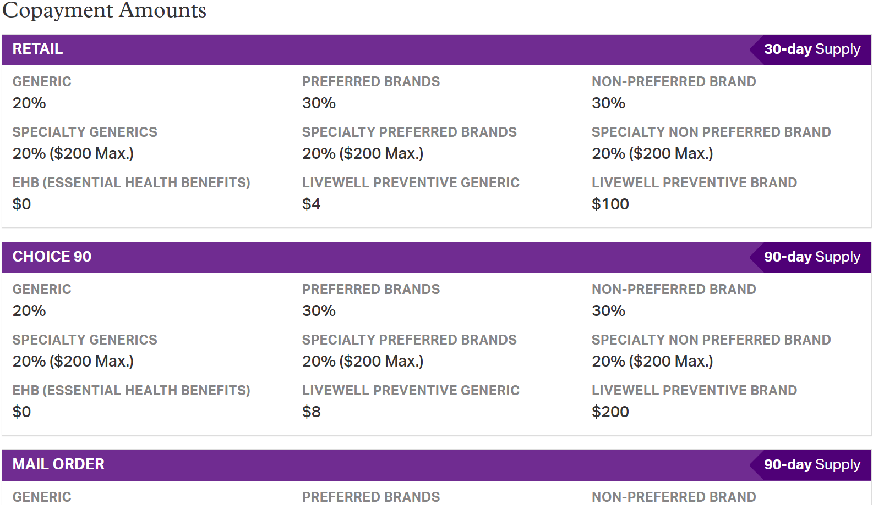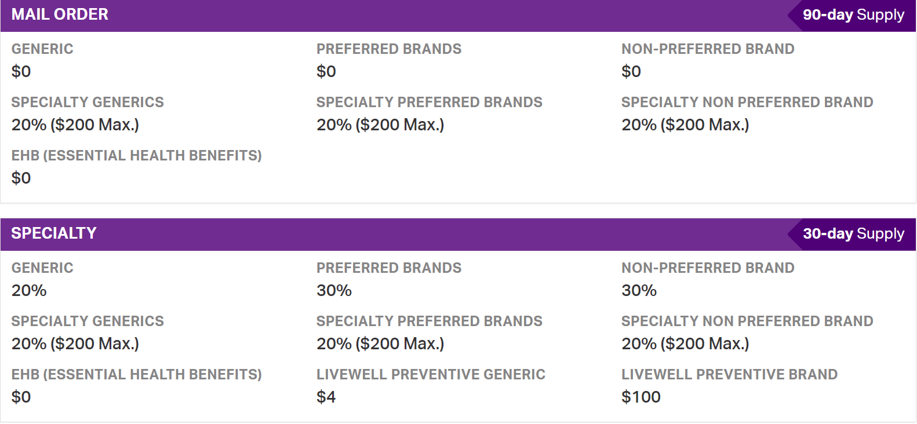

**Documents**

You can view and print documents from the document menu. The current available documents include the following:

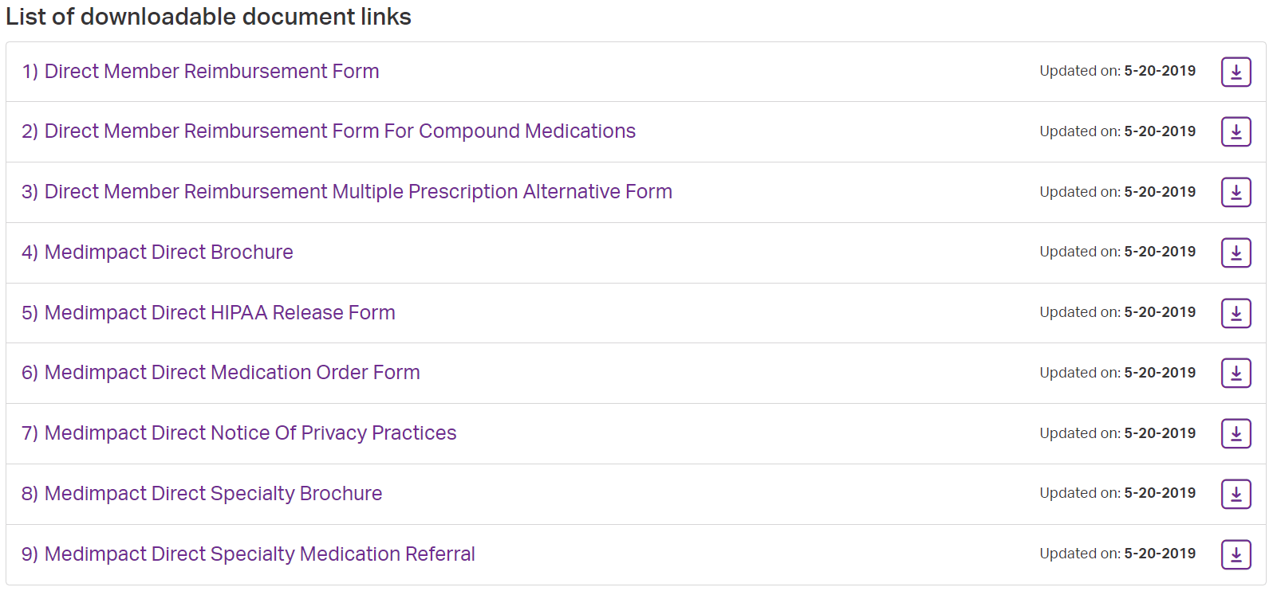

**Drug Price Check**

Drug Price Check allows you to see prices from multiple pharmacies. You can use it to find pharmacies with the best price.

In the header select “Drug Price”. If you type at least 3 letters of the drug you are looking for, results will show in a drop down. Select a drug from the drop down then enter a location. Your location can be city/state or zip code.

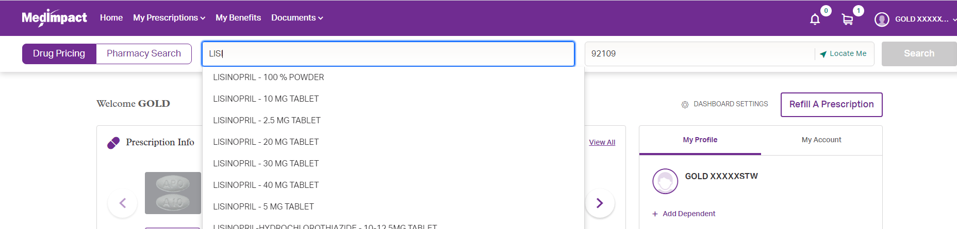

The search will display the following details:

1. Pricing summary showing the cost range for both local and mail order pharmacies
2. Drug information
3. Drug filter that will allow you to select
   * between brand and generic
   * drug form (tablet, capsule, cream, etc.)
   * drug strength
4. Local price tab with lowest price per day
5. Mail order price tab with lowest price per day
6. Savings calculator that will show additional savings opportunities
7. A best price icon “”, will appear under the tab with the lowest cost per day

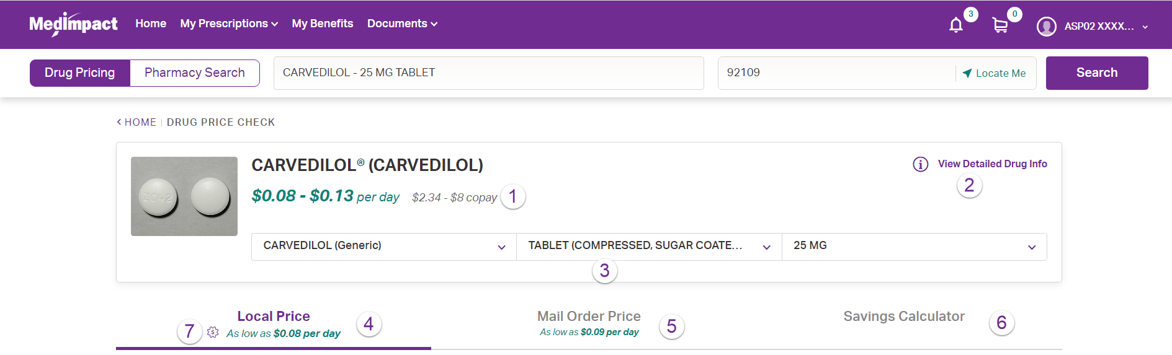

Local Price:

The following will show under the local price tab:

1. Quantity and days supply selection
   * There is a drop down with both the most common, and a free text box
   * Once your selection is made press “Update Search Results” to see new pricing
2. Sort by and location update
   * The sort by will allow you to sort by price or distance
   * The location update allows for a new zip code or current location
3. The pharmacy list area which has the following
   1. The price you should pay at the pharmacy (all prices are estimates)
   2. The price your plan pays on your behalf
   3. The status of your drug (tier, brand/generic, formulary)
   4. Pharmacy information
      * Clicking the name of the pharmacy will select it on the map
   5. Additional pharmacies with the same cost to you
   6. Directions on how to fill at the pharmacy and driving directions to the pharmacy
4. The map section has the following
   1. Color coded prices and icons
      * Clicking the icon will select the pharmacy in the list
   2. Click and drag map to search a new area

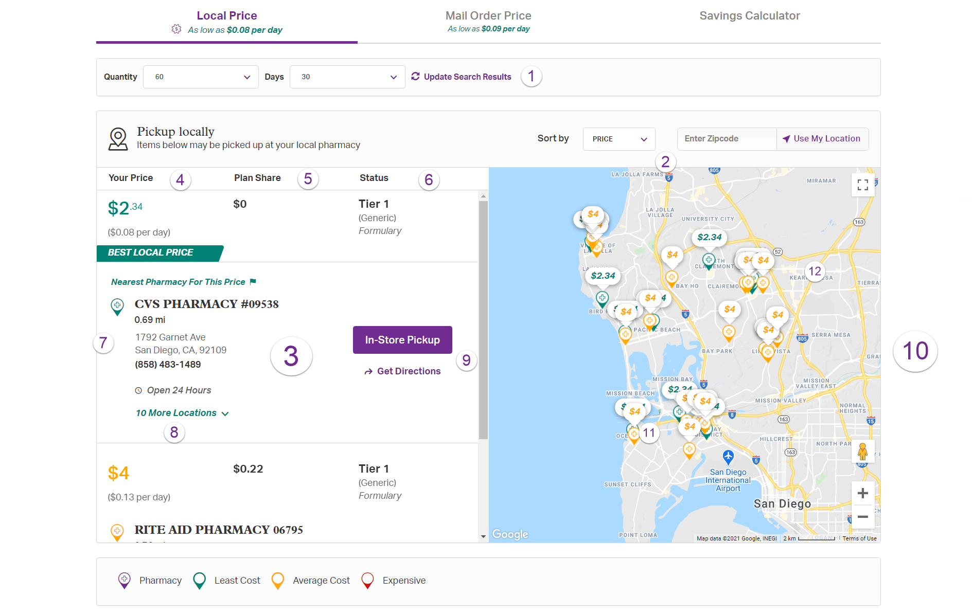

Mail Order Price:

The following appears under the mail order price tab:

1. Quantity and days supply selection
   * There is a drop down with both the most common, and a free text box
   * Once your selection is made press “Update Search Results” to see new pricing
2. The price you should pay at the pharmacy (all prices are estimates)
3. The price your plan pays on your behalf
4. The status of your drug (tier, brand/generic, formulary)
5. Pharmacy information
6. Directions on how to fill at the pharmacy
   * For MedImpact Direct only the button will allow you to request the drug if you don’t already have a prescription for it

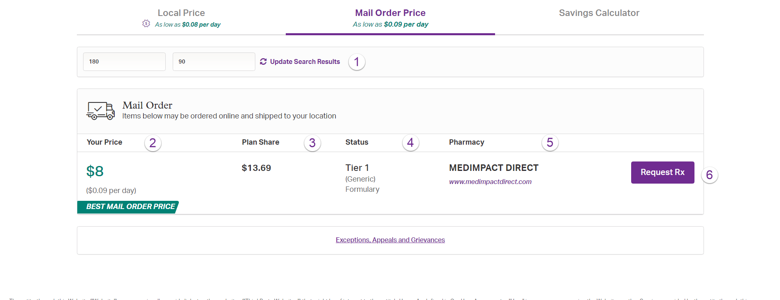

Savings Calculator:

The following appears under the savings calculator tab:

1. The option to view all savings options based on your claims
2. The option to change the pharmacy used for pricing
   * The lowest cost pharmacy is the default
3. Type of savings (similar drug, brand/generic, etc.)
4. The amount you can save (based on cost per day)
5. “Get Price” button that will do a drug search with the new drug

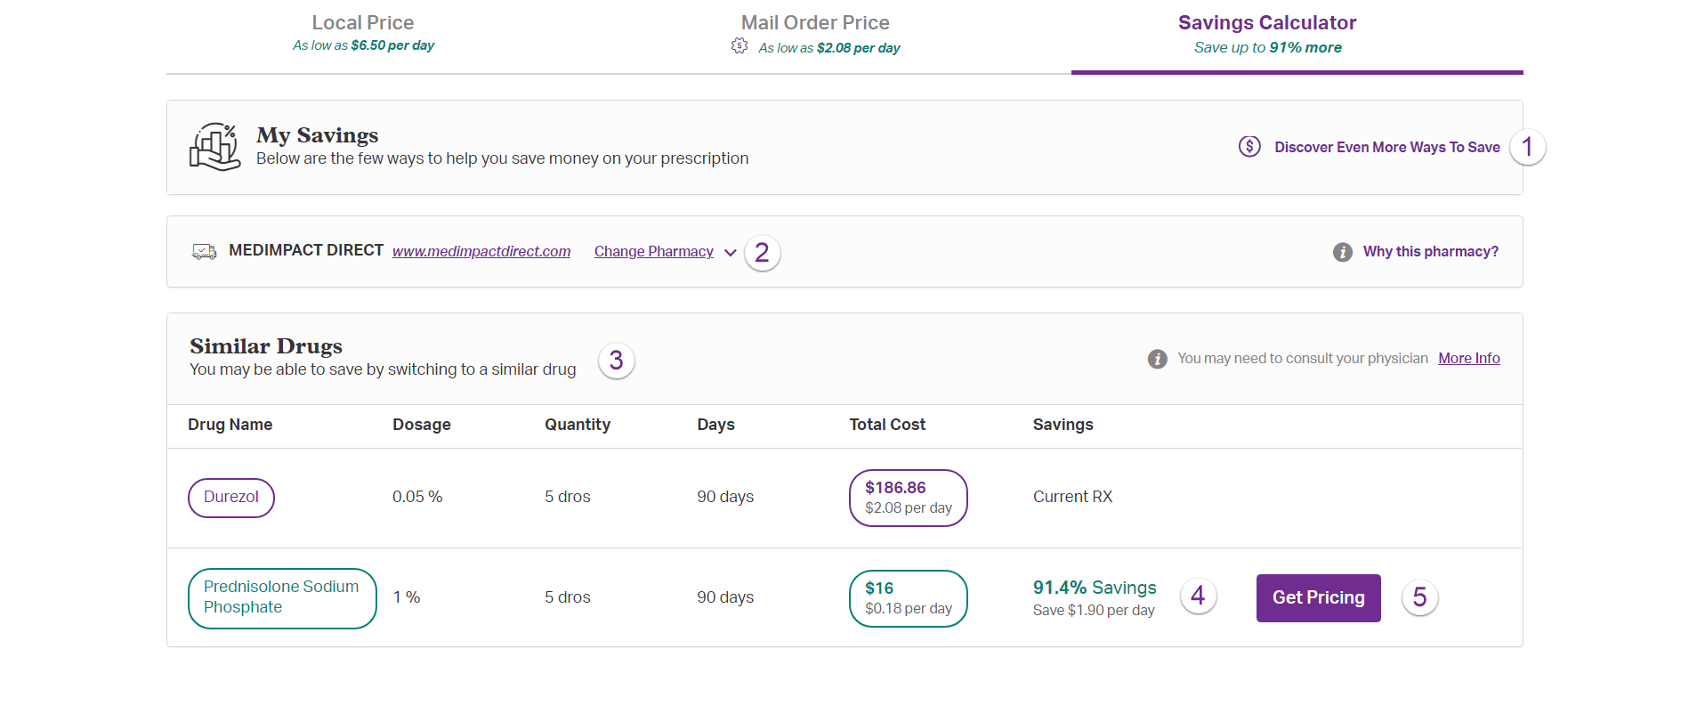

**Pharmacy Locator**

Allows you to find a pharmacy near you.

To see nearby pharmacies, you can search by:

* Valid city, state and zip code
* Your location by clicking the ‘My Location’ button  
  (Note: the location feature on your device must be turned on)



Your search results will show the following for in-network pharmacies in your area:

* Drug store name
* Street address
* Phone number
* Hours of operations
* Google map view with distance
* Directions

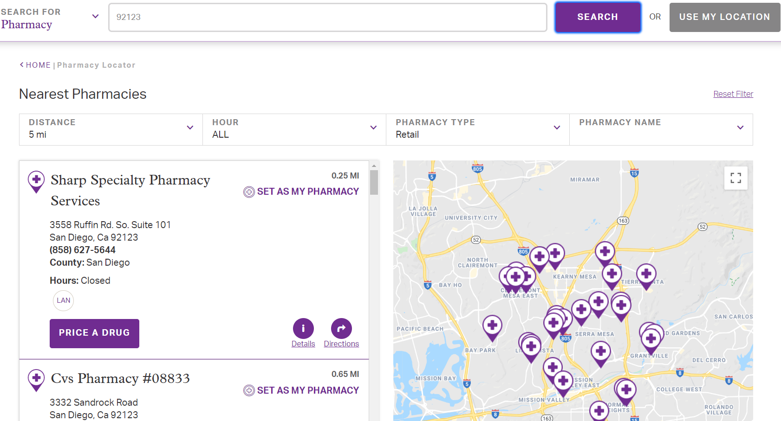

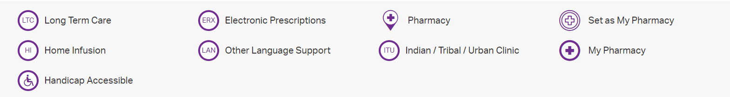

Preferred pharmacies will show a red star next to the name. You can save your favorite pharmacy by clicking on the Set as My Pharmacy icon.

You can filter the results of your search by using the filter options.

The filter options include:

* Mileage distance options
* Hours of operation
* Supply fulfillment channel (e.g.: Retail, Choice90)
* Plan preference
* Drug store name
* Directions

**Specialty Prescriptions**

Specialty medications are for chronic and complex medical conditions such as:

* Cancer
* Diabetes
* Hepatitis C
* Hemophilia
* Multiple sclerosis

Specialty medications typically require:

* Special handling (ex: refrigeration)
* Close monitoring to see how you are doing with the drug
* Complex administration of the drug (ex: injectable)

There are often additional savings opportunities for specialty drugs. For the most accurate cost details, please contact the phone number that is on the screen for assistance.

MedImpact Healthcare Systems, Inc.

10181 Scripps Gateway Ct. San Diego, CA 92131

Phone: 800.788.2949

MedImpact.com

Copyright © 2020 MedImpact Healthcare Systems, Inc. All rights reserved.

This document is confidential and proprietary to MedImpact and contains material MedImpact may consider Trade Secrets. This document is intended for specified use by Business Partners of MedImpact under permission by MedImpact and may not otherwise be used, reproduced, transmitted, published, or disclosed to others without prior written authorization. MedImpact maintains the sole and exclusive ownership, right, title, and interest in and to this document.