On-Line Benefits Enrollment Instructions

- Go to the district website: www.rsd66.org
- Scroll down and look for the Quick Links title on the left side of the page, Click on +For Staff and then on Financial & HR Portal.
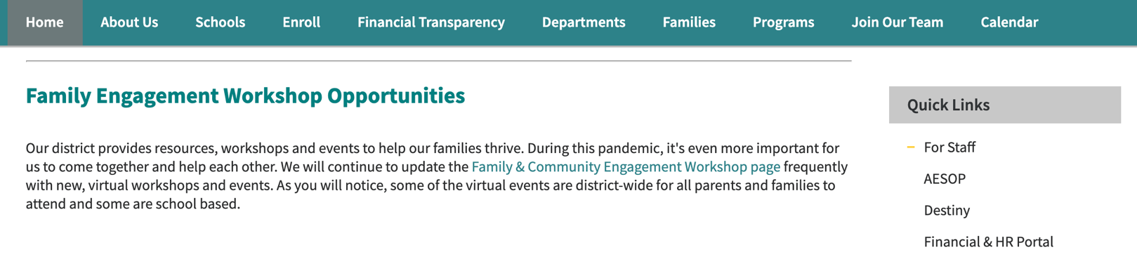
- Click Login on the top righthand side of the page.

- Enter Username (firstname.lastname) and Password (same one used to sign your contract) then click the Login button. If you have difficulty accessing the portal or you do not have a username and password, please contact the Technology Help Desk at (602) 232-4999 or from inside the district, extension 14357.
- Click on the Benefits tab then on Benefits Enrollment to begin the benefits enrollment process.

