**WEX|MHC Member Info and FAQ Sheet**

**General Information   
Who is WEX?** WEX Health, Inc. is Minnesota Healthcare Consortium’s (MHC) new partner for VEBA, HSA, FSA and Dependent Care FSA accounts. WEX is a global, publicly traded company well diversified with three distinct business units: corporate payments, fleet and health. The diversification allows us to remain financially stable and grow year over year. For the last 35 years WEX has offered an end-to-end benefit reimbursement and COBRA administration solution for service and technology. WEX has Midwestern office locations in Fargo, ND and Edina, MN.

**Who will help me if I have questions?** After the transition is complete, you can contact our Participant Services team via phone, email, or live chat. Participant Services will not have detailed plan or balance information for your account until your accounts have transitioned. Until the transition is complete, please continue to contact Further for questions about your existing plans.

WEX Participant Services: 1-866-451-3399

[customerservice@wexhealth.com](mailto:customerservice@wexhealth.com)

**How do I log in?** Once WEX receives your account information from Further, you will receive an Enrollment Confirmation Email to the email address currently on file with Further. The Enrollment Confirmation email will come from [auto_reply@mailer.wexhealth.com](mailto:auto_reply@mailer.wexhealth.com) and will guide you on setting up your online account. Below is a sample of the email.

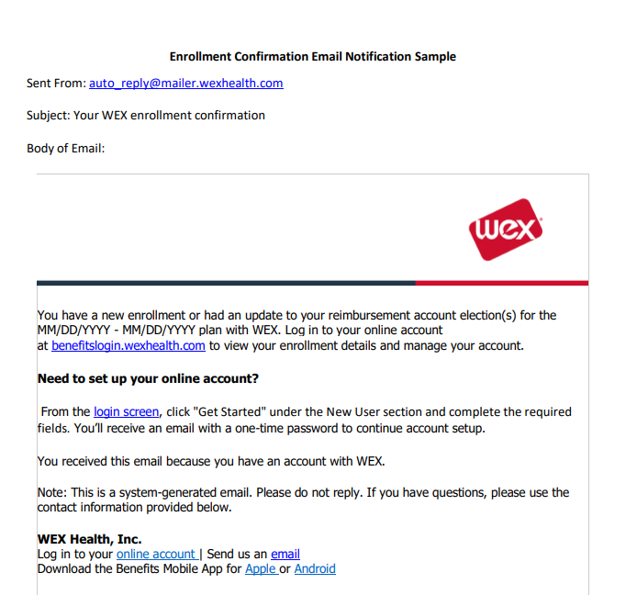

**What if I don’t have an email address on file?** If you don’t have an email address on file, contact WEX Participant Services after the transition is complete to assist you with setting up your online account. This online account will be required in order to accept terms and conditions for the HSA to access funds and assign beneficiaries for the VEBA account.

**What are my options for accessing my account?** Use your online account or download the free WEX Benefits Mobile App to access your account information in real-time. Here are a few examples of what you can do in the online account and mobile app:

* Check your balance
* Get instant updates on the status of your claims
* File a claim and upload documentation
* Scan an item’s barcode to determine if it’s eligible for reimbursement (mobile app only)
* Order additional cards or report a card as lost or stolen
* Access the knowledgebase to quickly search for answers to your questions

**Will I receive a debit card?** If supported by your plan,you’ll automatically receive two debit cards mailed to your home address. If you’d like to order a card for your spouse or dependent over the age of 18, you can do so in your online account. Below is a sample of the envelope to be on the lookout for that contains your cards. If you’re enrolled in multiple accounts (HSA and VEBA), you’ll use the same debit card to access funds from all of your accounts.

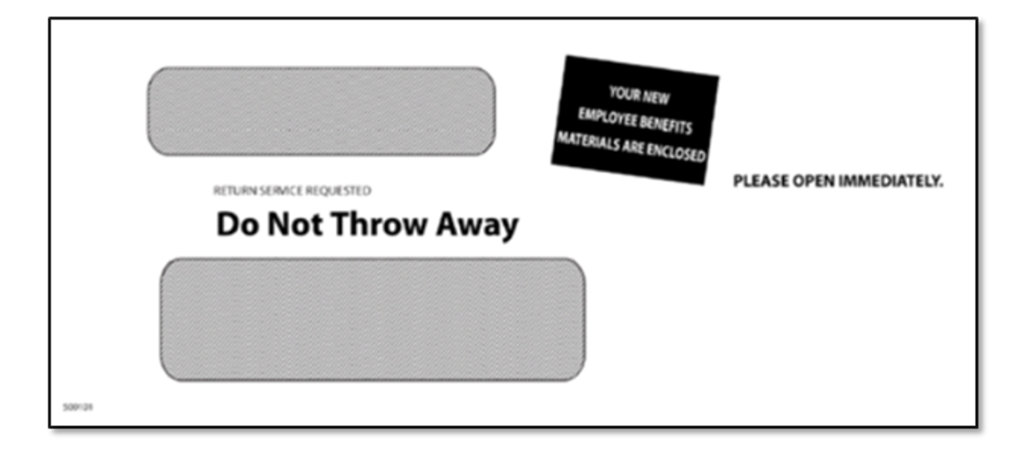

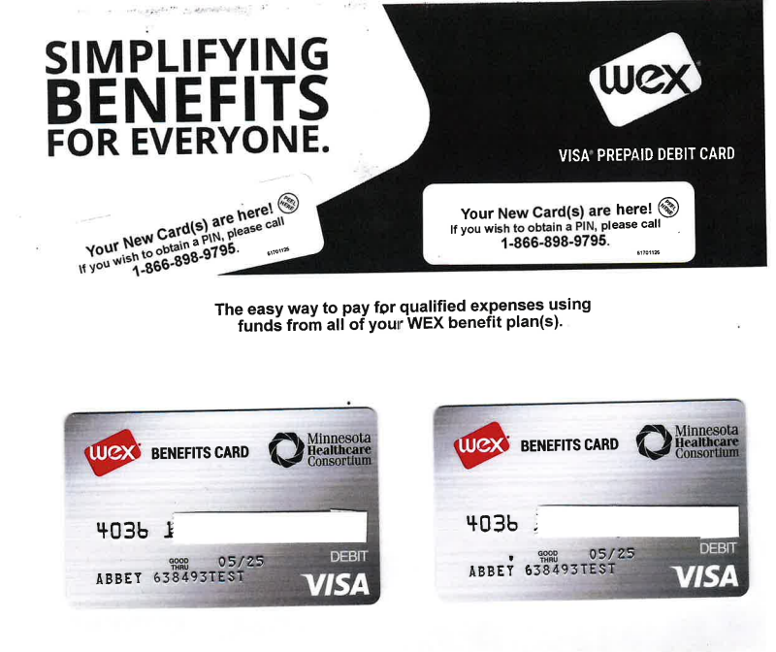

**When can I access my account?** Members can access their account when they receive the enrollment confirmation email. This email confirms your account and enrollments are available to view online.

**What order will my debit card pull claim activity in?** The standard plan ordering is FSA, VEBA, HSA. What this means is that if an expense is eligible within each of these plans for payout, it will pay out of the plan that has the available funds based on the above plan order. If you are eligible for both a VEBA and an HSA, you will want to consider this plan ordering in the second two weeks of September in which your HSA transition has been completed but VEBA transition is still pending. If you incur an expense from your HSA that you would later desire to have pulled from your VEBA, you are able to repay the HSA distribution and file a claim out of your VEBA account.

**Transition Dates:**

**8.18.22** - Last day to submit claims and cards disabled at Further.

**8.22.22** - Transition period begins Further

**9.1.22** - Plan is live but in a hold status

* Debit Cards to arrive 7-14 days following group submission of enrollments

**9.6.22** - HSA and VEBA assets transferred from Further to WEX

**9.15.22** - HSA funds to post to member accounts and FSA accounts become available.

**Between 9.21.22 and 9.26.22** - VEBA funds to post to member accounts. We will reach out to you in a separate mailing once this transition is complete

**How do I pay for medical expenses or prescriptions during the transition period?**

You can hold onto expenses that occur after the transition period has begun at Further. You will file these with WEX after the transition period is complete.

For VEBA/HSA reimbursements, most medical expenses have a window of time allowing you to hold payments until your account becomes available. Fill your prescriptions prior to 8/18/22 if you’re able to. During the transition period, you will need to use an alternate form of payment. Once the transition period is lifted, you will be able to be reimbursed.

**Health savings accounts (HSAs)  
Do I need to do anything before my HSA is active?** Since a new HSA is being opened, your information must be run through the Patriot Act identity verification process. This is a requirement for all HSAs. In the event further information is needed, WEX will reach out to you directly. In the event that no additional verification is needed, upon login, you will be prompted to review and accept terms and conditions for your HSA. This is a requirement to complete before you can utilize your card and funds.

**How do I request reimbursement from my HSA if I paid an expense out of pocket?**  You canrequest a distribution from your health savings account (HSA) through your online account or mobile app.

* There’s no time limit for requesting distributions.
* Distributions are tax-free for qualified expenses incurred.
* You’re not required to submit substantiation for HSA distributions. However, the IRS may ask you for it if you're audited.

**Do I need to add beneficiaries?** Yes. Beneficiary information will not be transferred to WEX from Further. You must provide beneficiary designations for your new HSA in your online account.

**How do I invest?** We make it easy to invest by offering a low HSA investment threshold of **$2,000**. Once an HSA reaches that balance, you can invest in interest-bearing accounts or mutual funds without ever leaving your online account or mobile app.

**Are there fees to invest?** WEX does not charge an additional fee to opt into the investment option.  
 **What is the maximum amount I can contribute to my HSA in 2022?** The IRS sets the annual maximum dollar amount you can elect and contribute to an HSA. The 2022 annual contribution limit is:

* Single coverage - $3,650
* Family coverage - $7,300

**What is the maximum amount I can contribute to my HSA in 2023?** The IRS sets the annual maximum dollar amount you can elect and contribute to an HSA. The 2022 annual contribution limit is:

* Single coverage - $3,850
* Family coverage - $7,700

Please note: If you’re 55 years of age or older, you are eligible to make an annual catch-up contribution, which lets you contribute an additional $1,000 on top of the above annual contribution limits. To determine your contribution, we recommend setting a goal based on what you plan to use your HSA for. Keep in mind you’re not locked into that decision and can change your contribution amount at any time.

**Will I receive HSA tax documents?** Yes. WEX will provide account holders with 1099-SA and 5498-SA tax forms. The 1099-SA shows distributions and the 5498-SA shows contributions. Both documents will be available in your online account by mid-February. The applicable document will generate based on whether you contributed or requested distributions.

**VEBA  
How can I access my VEBA funds?** We’re working with Further to transfer your VEBA funds to WEX. You’ll receive an email when funds are available. Once you log into your account, you will be able to link directly to your VEBA portal to see balances and make investment choices.

**When do my dollars invest?** Funds will be defaulted into a Lincoln Stable Value Fund “base” product. It is first dollar investing, meaning there is no minimum to invest. You also have access to a lineup of well diversified mutual fund investments for no additional fees outside of the standard mutual fund expense ratio paid to the investment manager of the mutual funds.

**Will my current investments be mapped to new investments at WEX?** Funds will not automatically be mapped. They will be defaulted into the Lincoln Stable Value Fund. This can be used as a guide to exchange investments into similar funds that they had under Further. Click here to find the comparison chart that offers suggested fund mapping.

**Is there a fee to invest?** There are no additional fees to invest.

**How do I file a claim?** If you choose to pay out of pocket instead of using the debit card, you can file a claim in your online account or mobile app to request reimbursement. You also have the option to file a claim to pay a provider directly instead of reimbursing yourself.

To get your money faster, you can enroll in direct deposit through your online account. Otherwise, we’ll mail you a check.

**Where do I find my VEBA account balance?** Your current VEBA account balance is available on the homepage of your online account. You may also view your account balance by choosing the following options from the Account Summary tab once you have accessed your “Manage My VEBA” from your online account.

· Fund Totals. Your account balance is displayed by investment fund.

· Source Totals. Your account balance is displayed by money source.

· Fund Detail. Your account balance is displayed by investment fund source.

· Source Detail. Your account balance is displayed by money source and investment.

**How do I view or change my investment elections for future contributions?** Click “Manage My VEBA” from the home page of your online account. Your current investment elections (that is, the manner in which your new contributions are invested by fund) are shown on your account home page.

* You may also select **Fund Election Change** from the **Transactions** tab. A table including all investment offerings within the plan will be displayed along with your current investment election percentages for future contributions. Simply enter your desired percentages next to each fund. The total must add up to 100%.
* Click “**Change Allocations.”** You will be prompted to confirm your entries before you submit the change.
* Click “**Confirm”** to process your requested change and receive your transaction confirmation number.

Note: If you do not receive a confirmation number after clicking “Confirm,” your transaction request will not be processed. All transactions must be initiated by 4 p.m. EST in order to be processed the same day (except on days when the U.S. stock market closes before 4 p.m. EST or is not open due to holiday).

**How do I obtain more information on our mutual fund offerings?**  From your online account, click “Manage My VEBA” and then navigate to the Fund Information tab. The following information is available:

Fund Links. Each investment option is displayed with links to:

* Historical prices
* Fund fact sheets
* Prospectus
* Morningstar and Financial Content, Inc. to perform additional research
* Fund Information.
  + This option provides the performance for each fund offering in the plan. You can view each fund prospectus by clicking the *P* next to the fund name and an online chart by clicking the *C* next to the fund name.
  + Any time you see a fund name underlined in blue, you can click on it to view performance information, expense ratios, and links to the fund fact sheet and prospectus.

**Will I receive VEBA tax documents?** Yes. 1099’s will be mailed to your address on file around January 31st annually. They will also be available electronically.

**Flexible spending account (FSA)  
Can I file a claim for dates of service during the transition period from Further?** Yes, you can file claims for out of pocket expenses incurred during your plan year once the transition to WEX is complete.

**How do I file a claim?** If you choose to pay out of pocket instead of using the debit card, you can file a claim in your online account or mobile app to request reimbursement. You also have the option to file a claim to pay a provider directly instead of reimbursing yourself.

To get your money faster, you can enroll in direct deposit through your online account. Otherwise, we’ll mail you a check.

**What can I use my FSA dollars for?** Your FSA covers thousands of eligible items. Some examples include:

* Copays and coinsurance
* Doctor visits and surgeries
* OTC medications (first aid, allergy, asthma, cold/flu, heartburn, etc.)
* Prescription drugs
* Birthing and Lamaze classes
* Dental and orthodontia expenses
* Glasses frames, contacts, prescription sunglasses, etc.

View our interactive eligible expense list at [**https://www.wexinc.com/insights/benefits-toolkit/eligible-expenses/**](https://www.wexinc.com/insights/benefits-toolkit/eligible-expenses/)**.**  Once you’ve downloaded the mobile app, you can scan the barcode of items to verify eligibility.

**Do I have to submit receipts?** Per IRS regulations, documentation will be requested for certain expenses. The IRS requires documentation showing date of service, type of service, merchant name, and amount. Most providers and merchants can provide you with an itemized receipt that includes the necessary information. We can also accept an Explanation of Benefits (EOB) from your insurance carrier. WEX has technology built into our debit cards that is able to auto approve certain expenses, including:

* Co-pay amounts that are pre-indicated by your group; and
* IIAS (Inventory Information Approval System) merchants.
  + Merchants can provide all IRS-required information right at the point of sale by using the IIAS. This computerized system allows the debit card to recognize items being purchased. IIAS merchants auto-substantiate claims, so you don't need to provide additional documentation for eligible expenses. After you swipe your debit card for the entire purchase, eligible items are approved and the merchant will ask for a secondary form of payment for any ineligible items.
* Recurring expenses.
  + Recurring expenses are a series of eligible expenses that occur at the same provider and for the same dollar amount. You must submit documentation the first time you swipe your debit card, but subsequent transactions at the same provider for the same amount are then automatically approved.

**How will I know if documentation is needed?** WEX will contact you via email if additional documentation is needed. If you don’t have an email address on file, we’ll contact you by mail. You can upload your itemized receipts or EOBs via your online account or mobile app or can send them via mail, email, or fax.

**Dependent care flexible spending account (dependent care FSA)   
Will I be able to file a claim for dates of service during the transition period?** Yes, you can file claims incurred during your plan year once the transition to WEX is complete.

**Can I use my debit card for dependent care expenses?** Yes. If your provider accepts a card as a form of payment, you can utilize your debit card for dependent care expenses.

**How do I file a claim?** You can file a claim in your online account or mobile app. Alternatively, you can complete a Recurring Dependent Care Request Form once per plan year to automatically receive reimbursement throughout the plan year as payroll contributions post to your account. To get your money faster, you can set up direct deposit in your online account. Otherwise, we’ll mail you a check.

**Who qualifies as a dependent**? A dependent is a person, other than you, who meets certain age and other requirements and for whom you can claim an exemption on your tax return. To be your dependent, a person must be your qualifying child or qualifying relative.

* Qualifying child
  + A child under 13 years of age or physically or mentally unable to care for himself/herself. Persons are considered unable to care for themselves if they:
    - Can't dress, clean or feed themselves.
    - Require constant attention to prevent injury to themselves or others.
  + A qualifying child must live with you for more than half the year.
* Qualifying relative
  + A qualifying relative must be related to you either by blood or marriage. Four tests must also be met:
    - Not a qualifying child test.
    - Member of household or relationship test.
    - Gross income test.
    - Support test.

**What expenses are eligible?** Adult daycare, before and after school care or extended day programs, agency fee for childcare, au pair, babysitter, back-up or emergency cares, and many more. For the full list, click [here](https://www.wexinc.com/insights/benefits-toolkit/eligible-expenses/) and select Dependent Care FSA in the Filter by Plan drop-down menu.

**What is the maximum contribution amount for 2022?** 2022 annual contribution limits are $5,000 per household and $2,500 per person (if married and filing separately).

**Can I change my dependent care FSA election mid-year?** In order to make changes to your election after open enrollment, you need to experience a qualifying life event. These events include:

* + - Change in marital status.
    - Change in the number of dependents.
    - Increase due to birth, adoption, or marriage.
    - Decrease due to death, divorce, or loss of eligibility.
    - Gain or loss of eligibility due to a change in member, spouse, or dependent employment status.
    - Change in daycare providers.
    - Child turning age 13.
    - Increase or decrease in the cost of qualifying daycare expenses.

If you experience a qualifying life event, contact your employer to make changes to your election.